Nottingham City Council
R2i
Emotional Literacy Assessment
Dr Elaine Looney

Step 1. Complete the below Emotional Literacy Child Assessment with the pupil.
This is a brief assessment of the student’s knowledge and understanding of the six basic emotions (anger, disgust, fear, happiness, sadness, surprise).
The student is presented with the visuals associated with each basic emotion. The assessment requires the student to demonstrate understanding in the following ways:
- Labelling the emotion associated with each visual
- Performing an associated facial expression
- Providing reasons why someone might feel this emotion
- Explaining how this emotion might feel (physical sensations)
- Giving an example of a time when they felt this emotion.

Basic Emotion | Facial Expression | Reasons why someone might feel this emotion | How this emotion might feel (physical sensations) | An example of a time when I felt this emotion
Anger | 
Disgust | 
Fear | 
Happy | 
Sad | 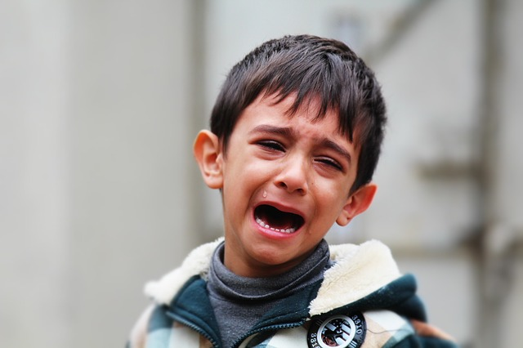
Surprise | 

Step 2: The assessor can use these ‘Emotional Literacy Outcomes’ to record the student’s skills in each area.
Emotional Literacy Outcomes | Yes/No (✔/X) | Comments
I can recognise and name the six basic emotions (anger, disgust, fear, happiness, sadness, surprise)
I can understand the reasons why I might feel different emotions

I can give examples of when I felt happy
I can give examples of when I felt sad
I can give examples of when I felt angry

I can give examples of when I felt scared

I can give examples of when I felt surprised

I can give examples of when I felt disgusted
I can tell you about some of the physical sensations I get when I feel an emotion
I can demonstrate appropriate facial expression to express different emotions
Step 3: The assessor should now complete the following Emotional Literacy Skills Checklist. This combines the outcomes of the above Emotional Literacy Child Assessment and the assessor’s knowledge of the child’s skills in this area.
Emotional Literacy Skills Checklist

Skill

Skill | Skill Level: Does the child/young person demonstrate this skill…
Skill | 3  Almost Never | 2  Sometimes | 1  Often | 0  Always
Following completion of the Emotional Literacy Child Assessment:
Names and identifies the basic emotions

Provides examples of what might evoke that emotion in themselves or others

Can match physiological experiences to different emotions

Can match facial expressions to different emotions

Based on your knowledge of the child’s skills in this area:
Recognises emotions in self

Recognises emotions in others
Verbally labels their emotions

Can offer an explanation as to why they are feeling a certain way
Makes emotional statements, e.g. ‘I am happy’, ‘That makes me upset’
Uses a wide emotional vocabulary/ ‘feelings words’
Demonstrates empathy towards others
Seeks comfort/reassurance or asks for help when feeling upset

Step 4: This assessment has indicated areas of strength and areas for development in the student’s emotional literacy skills. The assessor can summarise ‘areas of strength’ and ‘areas for development/targets to work on’ for the individual student. Ideas to support intervention activities are provided to support this work.
Areas of strength

Areas for development/Targets to work on | Possible intervention to support this

