The following resources are referenced in the Concepts Assessment Document.

- You will also need:
- Counters/cubes/buttons etc
- Large cloth
- Objects (shapes) to make repeated patterns

Resource Card 0 Numbers 1-10

1
2

5
6
4
3

7
9
8
10

Resource card 1 Subitising Dot cards



1
1

Resource 2 Sweets in a jar
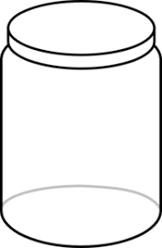



Resource 3 Picture Card frogs

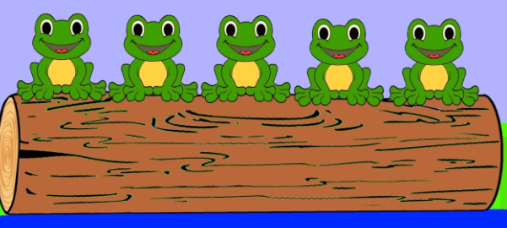

Resource 4 Number line

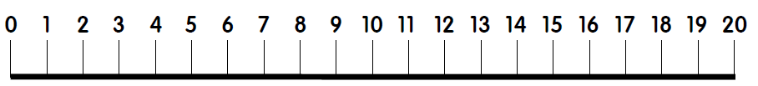

Resource 5 Missing numbers

Resource card 6a Ordinality activity



Resource card 6b Ordinality activity

If you write these numbers in order, smallest first, which number comes third?

7 13 23 3

Resource card 7 Number Words

 | zero
one | two
three | four
five | six
seven | eight
nine | ten

Resource card 8 Blue Marble shapes 1-10
Resource Card 8a Differing Sized Keys

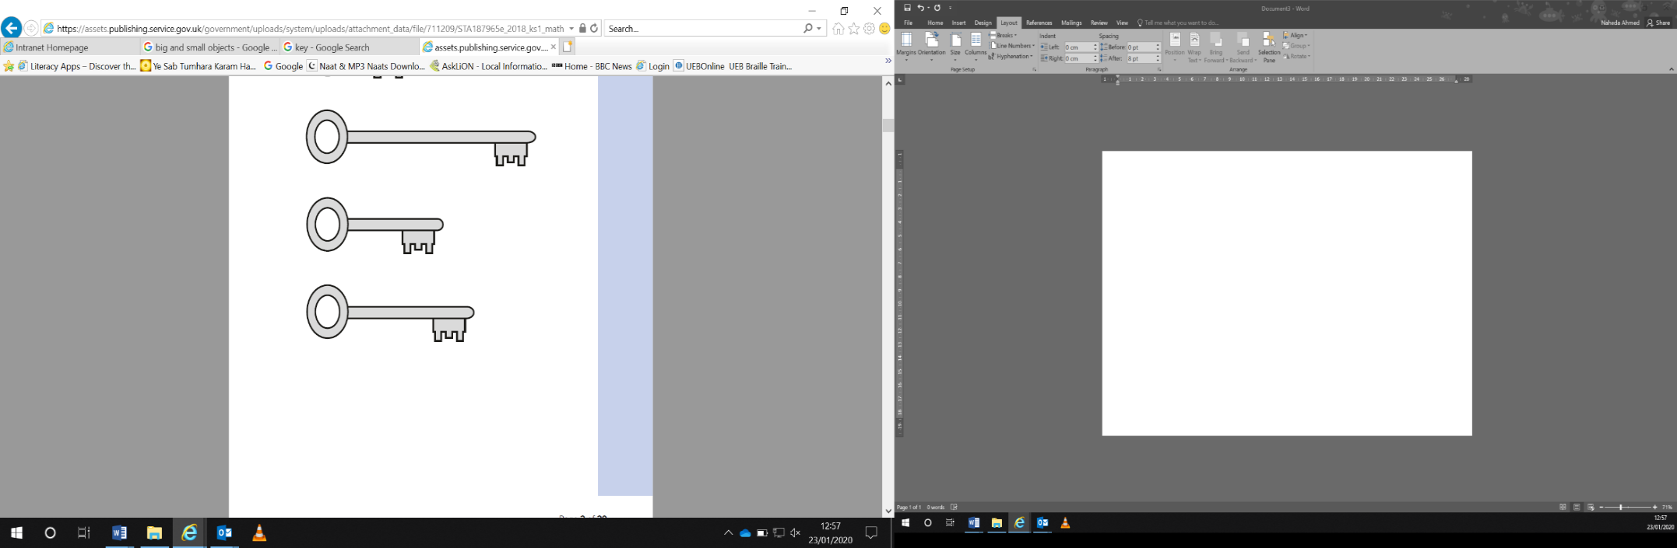
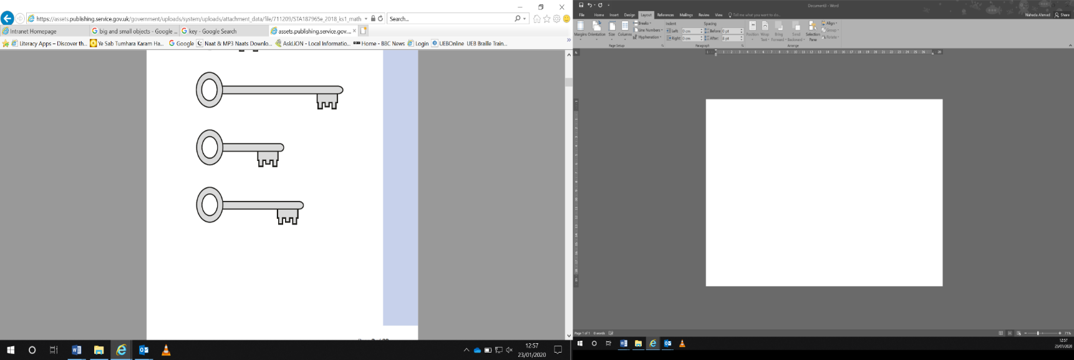
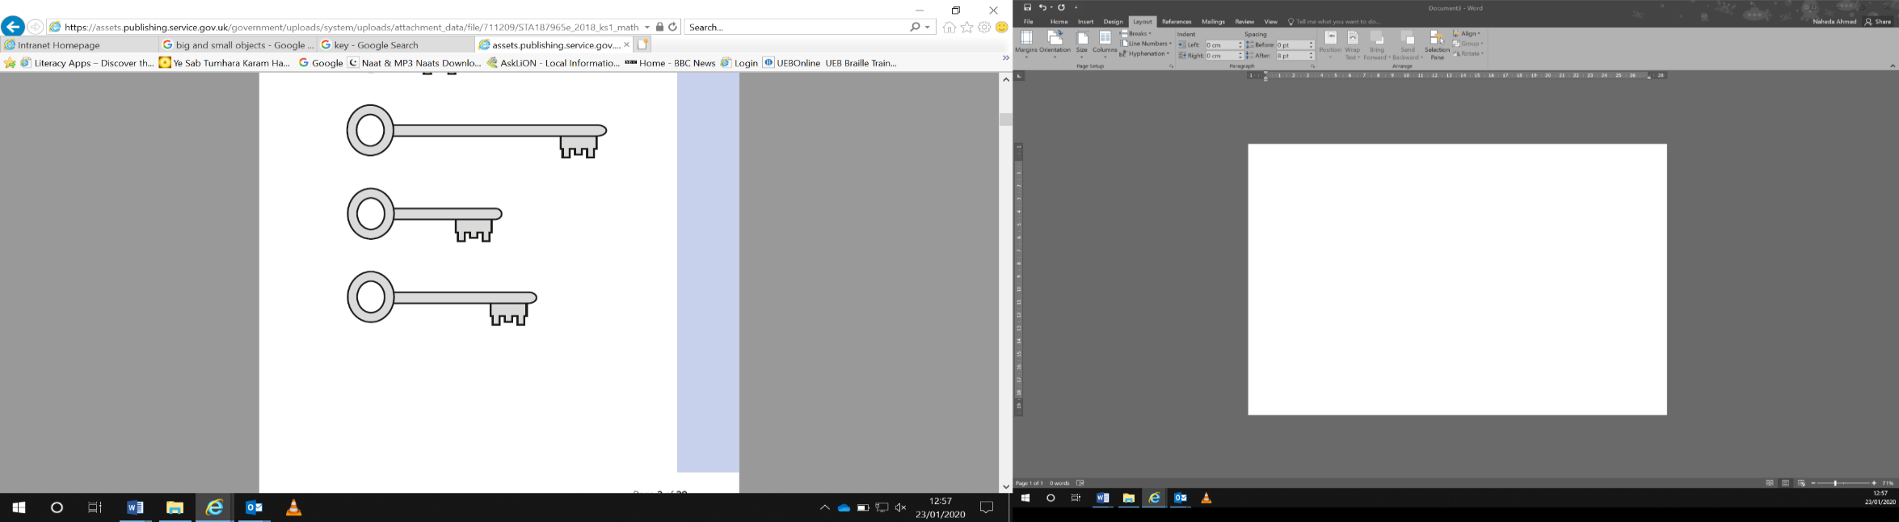
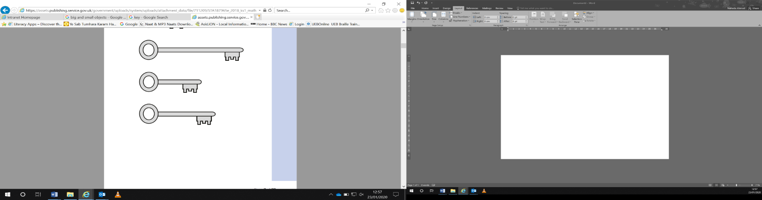

Resource Card 8b Ordering Towers

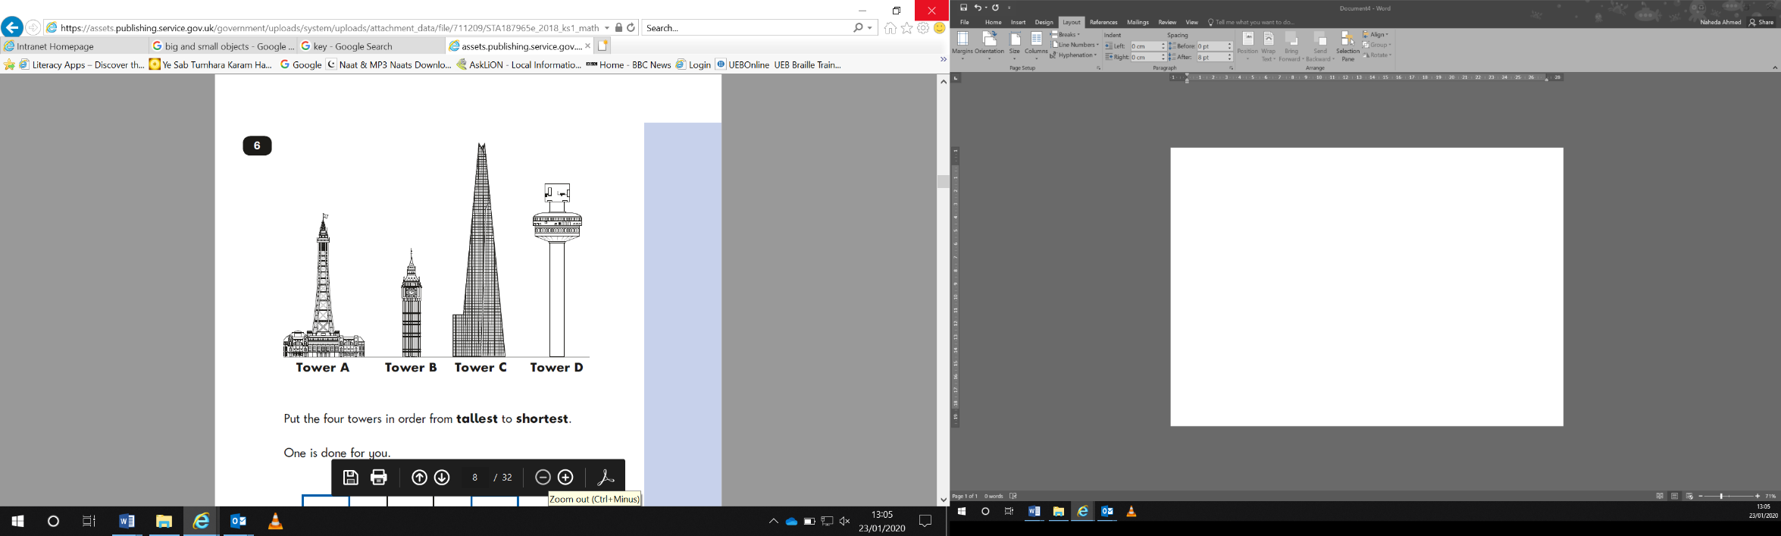
Put the four towers in order from shortest to tallest.

Resource card 9a: Shape patterns 1

What comes next?

Resource card 9a: Shape patterns 2

What comes next?

Resource card 9b: Number Bonds

