Phonological awareness assessment pack

If the young person experiences decoding difficulties, it will be helpful to understand more about their phonological awareness skills. This section has assessments to help you determine which phonological awareness skills the young person has acquired and which you should think about working on next, in order that the young person can develop strong decoding skills.

To complete the whole assessment pack will take approximately 1 hour, although it may be a lot less depending on the young person’s level of skill development. Below is a summary table which can be filled in as you progress through each assessment area. You can click on the links in the headings, and this will take you to each assessment.

Assessment name | What is it? | How it works | What can it tell you
Phonological Awareness Component Skill Assessment Pack | A series of tasks and activities for the young person to complete (e.g. sing nursery rhymes, copy words) | A member of the young person’s teaching team reads the scripted instructions and marks down the young person’s responses | Young person responses will reflect their phonological awareness abilities. Based on young person responses you can highlight the summary sheet. Any rows not highlighted will indicate a gap in phonological awareness and so an area to address.

Instructions for completing the assessment pack
Complete the short assessments for each phonological area with the young person. These assessments match the key component skills given earlier in the reading guide. Click on the links in the Summary Table to access each assessment.

Whilst you may find that an older young person can do some of the later skills but not the early skills (e.g. they may be able to blend but not rhyme), mostly, the skills will develop in sequential order – as highlighted in the Figure 1. Therefore, to prevent the young person from becoming distressed please stop the assessment once you feel the young person has reached their limit – i.e. once they have struggled on two of the tasks. At this point, it is unlikely that they will be able to complete any of the later tasks.

There are a number of tasks to complete, we recommend you break the assessment up and do not complete more than 3 tasks in one go.

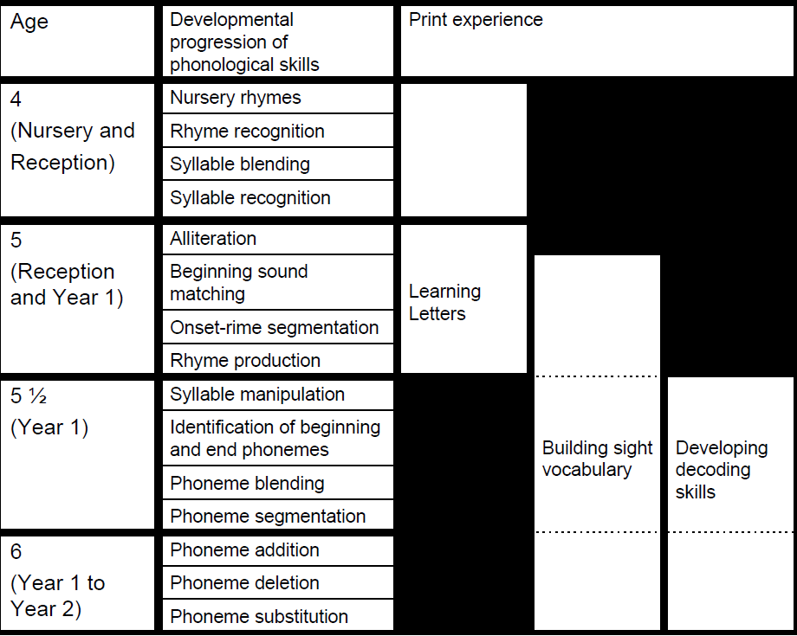
Figure 1. Developmental Progression of Phonological Awareness

We recognise that the progression of skills in Figure 1. may not match your phonics and reading curriculum. We have chosen to use the research-based progression chart as this moves from the largest units of sound to the smallest. Young people who have experienced a language-rich environment are likely to acquire many of the phonological awareness skills incidentally (particularly those pre-5 ½ years). However, in most cases, if young people are struggling to hear and manipulate larger units of sounds (e.g. syllables), they will find it difficult to hear and manipulate smaller units of sound. Intervention around small units of sound (e.g. individual phonemes) will thus be happening on a rocky foundation and may lead to the young person creating fuzzy representations which will then require further intervention.

Phonological Awareness Skill Summary

Young person: ……………………………………. Date: …………………………………….

Assessor: …………………………………. School: ……………………………………

 | Phonological skills area. Add comments where relevant. | Achieved? Y/N
1 | Nursery Rhymes. Can sing along to nursery rhymes
2 | Rhyme Recognition. Can recognise two rhyming words
3 | Syllable Blending. Can blend two or more syllables together
4 | Syllable Recognition. Can clap out syllables
5 | Alliteration and Beginning Sound Matching. Can identify when two words start with the same sound
6 | Onset-Rime Segmentation. Can split the world into its onset and rhyme parts
7 | Rhyme Production. Can give you a rhyming word
8 | Syllable Manipulation. Can swap one syllable for another
9 | Identification of Beginning and End Phonemes. Can hear beginning and end sounds?
10 | Phoneme Blending. Can blend phonemes together
11 | Phoneme Segmentation. Can segment a word into its individual phonemes
12 | Phoneme Addition. Can add a sound to the beginning and end of a word to make a new word
13 | Phoneme Deletion. Can take a sound away from the beginning and end of a word to make a new word
14 | Phoneme Substitution. Can swap one sound for another to make a new word

Nursery Rhymes

This task explores the young person’s ability to recognise and sing along with nursery rhymes.

Instructions
Say the following:
What’s your favourite nursery rhyme? Can you sing it for me?
[If the young person is reluctant offer to sing along with them. Allow the young person to finish of lines e.g. twinkle, twinkle little star, how I wonder what you …]
Shall we have a go at another?
You will quickly get an idea of whether the young person can sing along to nursery rhymes.

Comments:
The young person can sing along with nursery rhymes | Yes/no

Rhyme Recognition

This task explores the young person’s ability to hear the rhyme unit at the end of a word.

Instructions
Say the following:
Rhyming is when two words sound the same at the end, like
- ‘sand’ and ‘hand’, they both end with and,
- ‘pig’ and ‘wig’, they both end with ig,
- ‘rough’ and ‘tough’ both end in ‘ough’
I’m going to say two words I want you to tell me if they rhyme or not.
Let’s have a practice.
Cat, hat, do they rhyme?
[If young person hears the rhyme move on, if they don’t give three more examples before moving on to the items below]
- Sun and run, they both end with un
- Jack and back, they both end with ack
- Jar and tar, they both end with ar
Rhyming words are highlighted.
Correct/incorrect
Cup, pup
Milk, sun
Bus, duck
Rice, nice
Two, bird
Jump, bump
List, beep
Bee, knee
Hat, small
Row, bug
Boat, coat
Man, hill
Lamp, stamp
Stick and brick
Pink, climb
Freeze, breeze
Car, wood
Sip, chair
Creep, steep
Trick, flick

If the young person makes 5 or more errors on the highlighted pairs, it is likely that they are experiencing difficulty with Rhyme Recognition.

Syllable Blending

This task explores the young person’s ability to blend syllables together to make words.

Instructions
Say the following:
I am going to say some sounds. I would like you to put them together to make a word. Let’s have a practice first.
[Try to leave a half a second gap between each syllable]
- Train-er makes trainer
- Happ-y makes happy
- Pen-cil makes pencil
Now try on your own.
- Mon-key
[if you feel the young person has understood the task, move on to the main items in the table, if not complete the practice items below, modelling the first example with the young person, before moving on to the main items]
- Han-dle
- Doc-tor
 | Word created | Correct/Incorrect
Rab-bit
Don-key
Flow-er
Win-dow
Pic-ture
vi-o-lin
Cent-i-pede
Screw-drive-er
Hos-pit-al
Un-i-form

If the young person makes 5 or more errors, it is likely that they are experiencing difficulty with Syllable Blending.

Syllable Recognition

Instructions
Say the following:
I’m going to say a word. Then I’d like you to say the words and clap the beat. Let’s try some together
- Rain – rain
- Hedgehog – hedge-hog
- Crocodile - Croc-o-dile
Now have a practice on your own
- Party
[if you feel the young person has understood the task, move on to the main items in the table, if not complete the practice items below, modelling the first example with the young person, before moving on to the main items]
- Kettle
- Table
If the young person makes 5 or more errors, it is likely that they are experiencing difficulty with Syllable Recognition.

 | Answer Given | No. of syllables identified | Correct/Incorrect
apple
tiger
dragon
ladder
butterfly
Kangaroo
elephant
unicorn

Alliteration and Beginning Sound Matching

This task explores the young person’s ability to hear individual sounds at the start of a word.

Instructions
Say the following:
I am going to say some words. I would like you to tell me if they start with the same sound.
Let’s have a practice first.
- Cow and can [pause] they start with the same sound; they start with a/k/
- Dish and gate [pause] they don’t start with the same sound; dish starts with a /d/ and gate starts with a /g/. /d/ and /g/ are not the same sound. They’re different.
- Fall and face [pause] they start with the same sound; they start with a /f/
Now you try…
- Leg and lime and do they start with the same sound?
[if you feel the young person has understood the task, move on to the main items in the table, if not complete the practice items below, modelling the first example with the young person, before moving on to the main items]
- Sand and sit, do they start with the same sound?
- Gate and fish, do they start with the same sound?
[At this point, the young person does not need to identify the sound, they just need to say whether to sounds are the same or not]

Correct/Incorrect
Bus, bell
Lake, face
Toy, tip
Rat, race
Map, time
Fall, feet
Jug, jive
Sing, farm
Creep, clip
Sleep, grin
Stop, small
Crack, snail
Pram, black
Fry, flag
Drip, blink
Glee, grit

If the young person makes 8 or more errors, it is likely that they are experiencing difficulty hearing initial sounds.

Onset-rhyme segmentation

This task explores the young person’s ability to split a word into its onset and its rhyme.
Instructions
Say the following:
I’m going to say two words that sound the same. I want you to tell me which bit of the words sounds the same.
Let’s practice together.
- Cat and hat, both have ‘at’ at the end
- Sun and bun both have ‘un’ at the end
- Pig and wig both have ‘ig’ at the end.
Have a practice on your own.
- Hop, mop
[if you feel the young person has understood the task, move on to the main items in the table, if not complete the practice items below, modelling the first example with the young person, before moving on to the main items]
- Rain, pain
- Car, tar

 | Answer Given | Correct/Incorrect
Rock, mock
Bin, win
Chair, hair
Peg, leg
Van, ran
Sit, hit
Purse, curse
Top, mop

If the young person makes 4 or more errors, it is likely that they are experiencing difficulty with rhyme segmentation.

Rhyme Production

This task explores the young person’s ability to think of a rhyming word.

Instructions
Say the following:
I am going to say a word, I would tell me a word that rhymes with it. That means I would like you to give me a word that sounds the same at the end.
Let’s practice together.
- Hat rhymes with bat
- Light rhymes with night
- Nose rhymes with rose.
Now have a go on your own.
- Pole
[if you feel the young person has understood the task, move on to the main items in the table, if not complete the practice items below, modelling the first example with the young person, before moving on to the main items]
- Table
- Foot

 | Word Given | Correct/Incorrect
pot
fish
hair
side
beach
floor
score
clock
drill
brain

If the young person makes 5 or more errors, it is likely that they are experiencing difficulty with Rhyme Production.

Syllable Manipulation

This task explores the young person’s ability to manipulate a syllable – i.e. change the syllable for another to make a new word.

Instructions
Say the following:
We’re going to try and make some new words today. When you hear ‘er’ I want you to say cat instead. Let’s try some together.
- Runn-er goes to runcat
- Bake-er goes to bakecat
- Teach-er goes to teach-cat.
Now have a practice on your own.
- Daught-er
[if you feel the young person has understood the task, move on to the main items in the table, if not complete the practice items below, modelling the first example with the young person, before moving on to the main items]
- Numb-er
- Bett-er

 | Answer | Correct/Incorrect
leader
Sister
Silver
Worker
Winner
Answer

If the young person makes 3 or more errors, it is likely that they are experiencing difficulty with syllable manipulation.

Identification of Beginning and End Phonemes

This task explores the young person’s ability to hear sounds at the beginning and end of words.

Instructions
Say the following:
I’m going to say some words. I want you to tell me what sound they start with. Let’s have a go together.
- Six starts with /s/
- Kick starts with /k/
- No starts with /n/
Now have a practice on your own
- Goat starts with
[if you feel the young person has understood the task, move on to the main items in the table, if not complete the practice items below, modelling the first example with the young person, before moving on to the main items]
- Bed starts with
- Hand starts with

 | Answer Given | Correct/Incorrect
boy
end
love
rat
cloud
prince

If the young person makes 3 or more errors, it is likely that they are experiencing difficulty identifying initial sounds.

Now I’m going to say some words and I want you to tell me what sound they end with. Let’s have a go.
- Shut ends with /t/
- Hill ends with /l/
- Can ends with /n/
Now have a practice on your own
- zip ends with
[if you feel the young person has understood the task, move on to the main items in the table, if not complete the practice items below, modelling the first example with the young person, before moving on to the main items]
- dove ends with
- head ends with

 | Answer Given | Correct/Incorrect
bag
rub
wake
roam
just
hand

If the young person makes 3 or more errors, it is likely that they are experiencing difficulty identifying end sounds.

Phoneme Blending

This task explores a young person’s ability to blend phonemes (individual sounds) together to make a word.

Instructions
Say the following:
I’m going to say some sounds. I want you to put them together to make a word. Let’s have a go together.
[Leave a half a second pause between each phoneme]
- /s/ /i/ /t/ makes sit
- /m/ /o/ /s/ makes moss
- /l/ /a/ /p/ makes lap
Now have a practice on your own.
- /j/ /u/ /g/
[if you feel the young person has understood the task, move on to the main items in the table, if not complete the practice items below, modelling the first example with the young person, before moving on to the main items]
- /r/ /a/ /t/
- /sh/ /i/ /p/

 | Answer Given | Correct/Incorrect
/c/ /a/ /p/
/l/ /i/ /k/
/h/ /u/ /g/
/sh/ /o/ /p/
/p/ /e/ /n/
/g/ /l/ /a/ /s/
/b/ /r/ /u/ /sh/
/s/ /t/ /ar/ /t/
/f/ /l/ /a/ /p/
/d/ /r/ /o/ /p/

If the young person makes 5 or more errors, it is likely that they are experiencing difficulty with phoneme blending.

Phoneme Segmentation

This task explores the young person’s ability to break a sound up into its individual phonemes.
Instructions
Say the following:
I’m going to say some words. I want you to split the word into its sounds. Let’s have a go together.
- Fun splits into /f/ /u/ /n/
- Pet splits into /p/ /e/ /t/
- Hop splits into /h/ /o/ /p/
Now have a practice on your own.
- Tip
[if you feel the young person has understood the task, move on to the main items in the table, if not complete the practice items below, modelling the first example with the young person, before moving on to the main items]
- Mouse
- Gel

 | Answer Given | Correct/Incorrect
good
date
like
fish
prize
stop
flip
block
Milk
lunch

If the young person makes 5 or more errors, it is likely that they are experiencing difficulty with phoneme segmentation.

Phoneme Addition

This task explores the young person’s ability to add a sound to a word to create a new word.

Instructions
Say the following:
I’m going to say a word. I would like you to add a sound to the start of the word to make a new word. Let’s try some together.
- Add /w/ to itch to make witch
- Add /b/ to ring to make bring
- Add /k/ to rack to make crack
Now practice on your own.
- Add /r/ to ice to make…
[if you feel the young person has understood the task, move on to the main items in the table, if not complete the practice items below, modelling the first example with the young person, before moving on to the main items]
- Add /s/ to and to make…
- Add /g/ to loo to make…
 | Answer Given | Correct/Incorrect
/s/ to top
/g/ to low
/s/ to nap
/t/ to rail

Now add the sound to the end of the word. For example, add /p/ to dam to make damp. Now you try.
 | Answer Given | Correct/Incorrect
/k/ to sin
/p/ to gull
/d/ to ban
/t/ to plan

If the young person makes 4 or more errors in total, it is likely that they are experiencing difficulty with phoneme addition.

Phoneme Deletion

This task explores the young person’s ability to remove a phoneme from a word to make a new word.

Instructions
Say the following:
I’m going to say a word. I would like you to take a sound a way to make a new word. Let’s have a practice together.
- Take the /k/ away from pink to make pin
- Take the /p/ away from carp to make car
- Take the /l/ from buckle to make book
Now practice on your own
- Take the /n/ from bean to make
[if you feel the young person has understood the task, move on to the main items in the table, if not complete the practice items below, modelling the first example with the young person, before moving on to the main items]
- Take the /l/ from pile to make
- Take the /t/ away from lost to make
 | Answer Given | Correct/Incorrect
Take the /p/ away from gasp
Take the /d/ away from held
Take the /t/ away from bell
Take the /k/ away from think

If the young person makes 2 or more errors, it is likely that they are experiencing difficulty with phoneme deletion.

Phoneme Substitution

This task explores the young person’s ability to swap one phoneme for another to make a new word.

Instructions
Say the following:
I’m going to say a word. I would like you to swap two of the sounds. Let’s have a practice together.
- Swap the /p/ in push for a /r/ to make rush
- Swap the /m/ in map for a /l/ to make lap
- Swap the /r/ in rug for a /j/ to make jug
Now practice on your own.
- Swap the /h/ in hat for a /s/ to make
[if you feel the young person has understood the task, move on to the main items in the table, if not complete the practice items below, modelling the first example with the young person, before moving on to the main items]
- Swap the /b/ in bag for a /w/ to make
- Swap the /k/ in core for a /sh/ to make
 | Answer Given | Correct/Incorrect
Swap the /p/ in peg for a /l/
Swap the /n/ in nose for a /r/
Swap the /b/ in box for a /f/
Swap the /h/ in hug for a /j/
Swap the /w/ in weep for a /s/
Swap the /p/ in spit for a /l/ to make
Swap the /b/ in blood for a /f/ to make
Swap the /r/ in free for a /l/ to make
Swap the /n/ in snack for a /m/ to make
Swap the /l/ in sleep for a /w/ to make

If the young person makes 5 or more errors, it is likely that they are experiencing difficulty with phoneme substitution.

