Supporting children’s understanding

This document has been designed by the Children’s Speech and Language Therapy department as a tool to support children with comprehension difficulties. It provides information for parents and school staff about children’s understanding difficulties and ways to support them.

Contents Page
Spiral of Understanding, noticing when a child doesn’t understand 2
Understanding: What Is It and How Do We Do It? 3
Things which affect understanding 5
How to Help 7
References 9



© Nottingham Children’s Speech and Language Therapy Service 2025

The spiral of understanding and noticing when a child doesn’t understand.

Understanding is a complicated process. Difficulties with understanding impact in many ways.
This diagram shows the types of behaviors seen in children who have difficulties with understanding.

A child who doesn’t understand is likely to…
…switch off.

…become quiet and lose their confidence.

…stop taking part in things.

…be distracted.

…avoid tasks and instructions.

…become disruptive in lessons.

…find it trickier to learn.
If you notice some of the things on the left side of the spiral, then it might mean that the child is finding it tricky to understand. If a child is finding it tricky to understand they might also….not look at you when you speak to them, find it tricky to pay attention, try and delay or avoid things, sometimes have a blank look on their face, not start something at the same time as everyone else, copy others, not answer a question quite right, hide, misbehave, not be able to tell you what they should be doing, just do part of an instruction, find it hard to have a conversation (Andrews et al, 2002-2003)

…find it difficult to understanding what they read.



A child who is helped to understand is
likely to…

…listen and concentrate.

…share their ideas.

…learn new words.

…be more interested and want to learn.

… to do what is asked.

… to sit still.

…have less things get in the way of their learning.

Understanding: What is It and How Do We Do It?
To understand everyday talking, we count on clues from the situation and things that aren’t said like routines, gestures, pointing, tone of voice, objects, and sounds.
Understanding involves all these things.
To understand well you must understand what is being said and things that are happening around you.
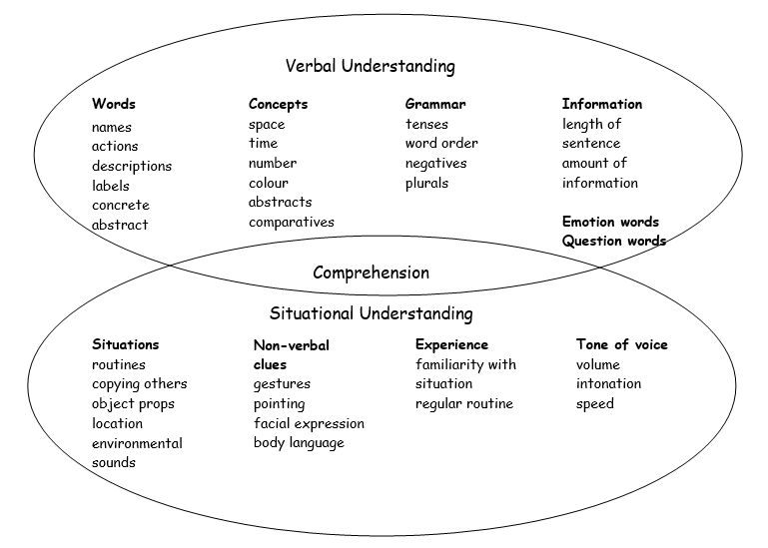

It’s tricky to know how much somebody understands.
We normally try and figure out how much someone can understand by how they respond to us or their behavior.
Children can understand different amounts at various times because they have different clues.
If we are talking about something more complicated, then we can give some more clues. This diagram gives you some ideas of things you can do to help.

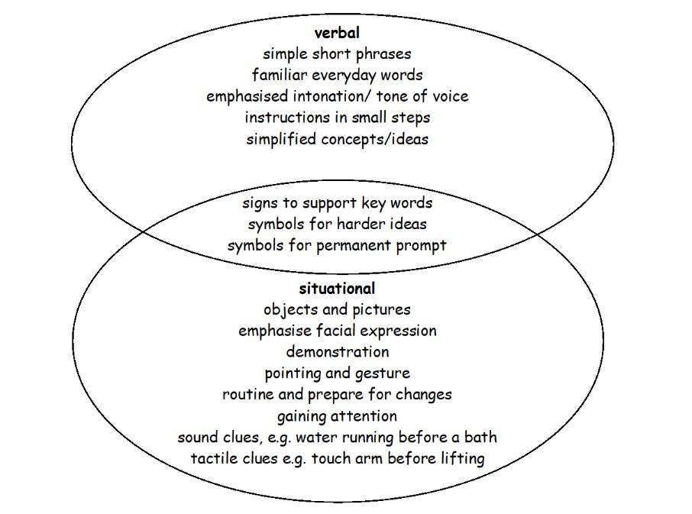

 Some children can say full sentences but not understand all the words they are using.


Understanding language normally happens in these stages.
First | - Understand their own routines.  - Understand that objects and actions represent a word.  - Understand gestures and other non-verbal clues
Then | - Link objects, actions and experiences to words and concepts.  - Understand sentences.  - Understand grammar (the rules in the language)
Finally, | - Understand lots of sentences together.  - Understand conversation.  - Understand figures of speech such as idiom and metaphor, for example, “pull your socks up”
 If you want to read more about ages and understanding look at this website: https://speechandlanguage.org.uk/help-for-families/ages-and-stages/

Blank Levels
Blank levels are 4 different levels of questions created by Marion Blank. They go from simple questions to more tricky, abstract questions. When we know what levels of questions a child is working at, we can make sure we ask them questions at that level so that they will understand. We can also help them to understand questions from the next level and develop more skills in understanding like inferencing and problem solving.
Here are some examples of Blank level questions.
If you want to learn more or see how you can help children with them here are some videos to watch.
Overview
Blank Levels of Questioning Overview
How to use Blank levels at home
How to use blanks at home
Some examples
Blanks at home - Living room
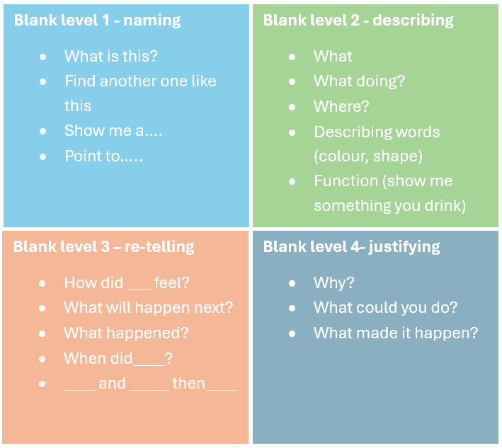

Things that affect understanding


Understanding goes up and down.
It goes up and down because of things to do with the child, the person talking to the child, where they are and what’s going on.
Imagine that a child is finding it difficult to understand when you ask them a question or ask them to do something. Here are some reasons why they might be finding understanding you tricky.
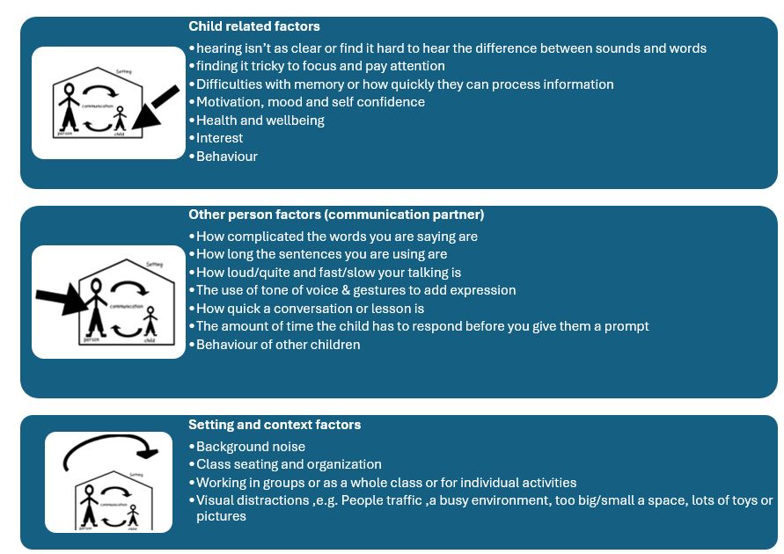

Research shows that it won’t always be possible to change a child’s skills in understanding language through practicing or therapy activities but finding things tricky to understand can be made-up-for (compensated for) by making changes to the environment and other people using strategies to support them

To help know when a child is finding it tricky to understand and why it can be helpful to think about times when understanding doesn’t go to plan.

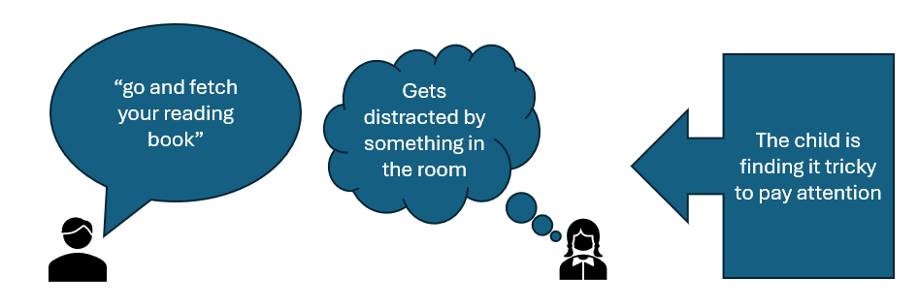

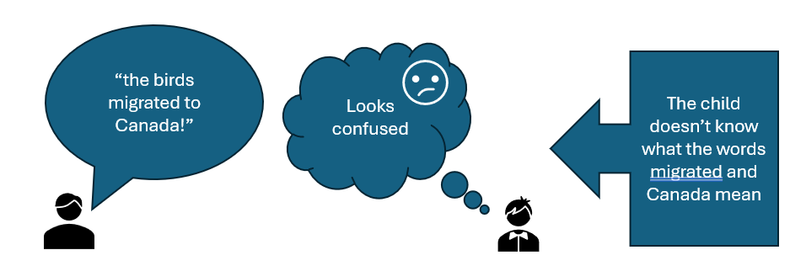

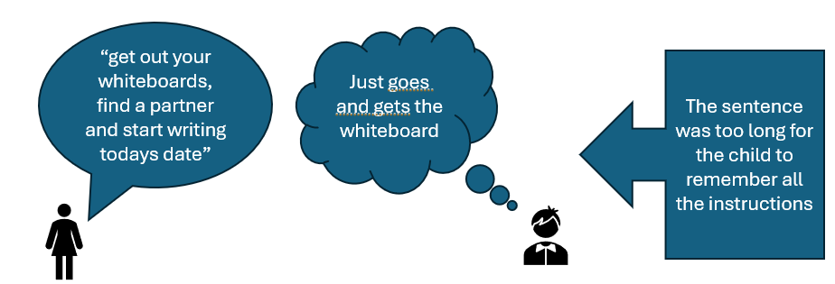

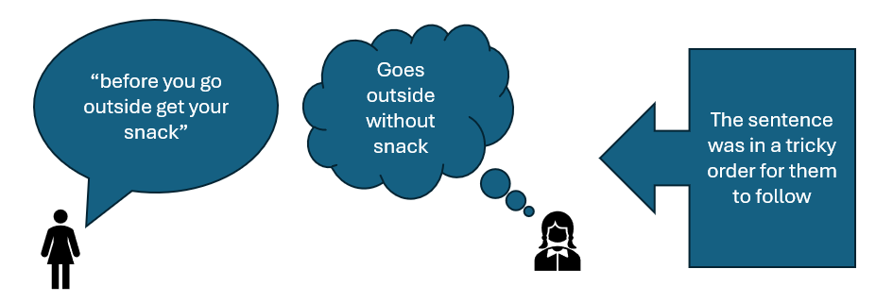

Things like jargon, long words, unfamiliar words, no intonation, long sentences, no context, and no clues can make it tricky for children to understand.
Andrews et al (2002 -2003) appendix 6

Here are some changes and strategies you can try to help children understand:
How to help

Focus attention - Make sure the child is looking at you and listening. For example, say their name to get their attention before you tell them something.




Give it some time - Help the child to wait until you have finished speaking.

Give the child enough time to respond e.g., Try counting to 10 in your head before helping them. If they don’t respond pause and try saying it again.


Show them - The best way to help understanding is to demonstrate or help them experience an activity.

Simplify - Use simple words and speak slowly and clearly. Think about the right Blank level question. Get to the point “get your book.”

Match and Stretch - Try and keep language one step ahead of the language the child uses. For example, if the child only uses one word on its own, use words on their own or short phrases when you speak. Think about the child’s stage of language development rather than their age.

Use shorter sentences – Instead of “We’re going to do some craft now; I want you to get some scissors from the craft corner” try “get the scissors” (whilst pointing and gesturing to the craft folder), pause, ‘ let’s do some craft.’
Say things in the order you want the child to do them – instead of “before you go in the dining hall you need to wash your hands” try “wash your hands, then go for dinner” (add some actions)

Use positive statements – instead of “don’t run” try “walk”

Break information into chunks – instead of “The great fire of London was a catastrophe because it rapidly became a fire storm with temperatures Over 1000C,spread at a rapid rate, resulted in extensive destruction and raged for a longtime.” Try The great fire of London was a big problem.” “The fire was very hot.” “The fire moved quickly.” “The fire burned for a long time.” “Lots of houses were burnt down.” If you give an instruction give one instruction at a time and wait for them to finish the first bit until you give them the next bit
7

Check the child understands –
- Ask simple questions “What have you got to get?”
- Ask the child to say what you have asked him/her to do.
- Ask the child to say what has been said or to repeat the key points.
- Can they show you what they need to do?
Sometimes too many questions can be overwhelming. If they are getting upset, it is best just to show them again, start the activity with them, or stop, let them relax, then try again.

Choices - If a child is finding it tricky to answer a question give them a choice “orange or apple.”

Gestures – Use gestures and pointing to help the child understand or cue him into the answer.

Signs and symbols – Use signs and/or symbols at the same time as keywords.

Use visuals, they are important for:
- Supporting attention and focus
- Making the information more permanent
- Reducing the load on the child’s memory
- Clarifying information or supporting explanations e.g., a picture to support the concept of shadows.
- You could do quick drawings, use pictures, symbols or real objects, visual timetables, now and next boards and mind maps.

It’s important that children are told that it is ok if they don’t understand something and that they are encouraged to as for help when they need it. Children might need help to tell you when they don’t understand.

References:
Blank,M.,Rose,S.andBerlin,L.(1978).The)Language)of)Learning:)The) Preschool)Years.)NewYork:Grune&Stratton

Books
Hayden,S.andJordan,E.(2004)Language for Learning: A practical guide for supporting pupils with language and communication difficulties across the curriculum. London:Fulton
Speake,J.(2003).How to Identify and Support Children with Speech and Language Difficulties.Cambridge:LDA

9

