Visuospatial shape and space resource

- Show me the pentagon.
- How do you know?

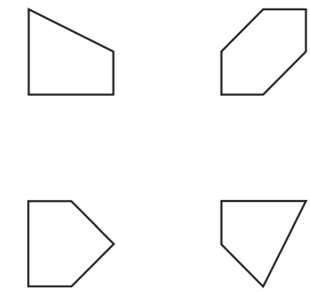
Which two shapes have more than 8 edges?

