Assessment name | How it works |  | What it can tell you
SLCN Age-Specific screener  KS1 Age 5-6y11m | This screening tool is for use with children aged 5 years 0 months – 6 years 11 months to find out what support you can give the child in your setting.  It is also designed to support you in deciding when you need to refer to the Speech and Language Therapy service (SLT). This is based on the service’s referral criteria found here on our website: https://www.nottinghamshirehealthcare.nhs.uk/slt-how-to-refer  Please base your answers on the child’s first (strongest) language. The child should only be referred to SLT if he/she has difficulties in his/her first language. When assessing a child with English as an additional language, please bear in mind:  It can take up to 2 years for a child to acquire a good level of conversational ability in their second language.  It can take 5-7 years for the child to use the second language to process learning tasks in the same way as they would use their first language. |  | Children who score amber will require support with their speech and language development. You should look for advice on universal strategies and targeted interventions found here on our website:  Children who score red will require support with their speech and language development. You should look for advice on universal strategies and targeted interventions found here on our website: https://www.nottinghamshirehealthcare.nhs.uk/cslt-support-and-advice  Refer to speech therapy (use our criteria checklist) if a child scores red in any of these areas:  - Vocabulary and word finding  - Spoken Language  - Speech sounds  - Stammering and voice  They may also score red in other sections too.  Continue to implement interventions in the padlet whilst the child is waiting to be seen by speech therapy.  Implement advice in the padlet for those scoring red ONLY in:  - Attention and listening and/or  - Understanding  Reconsider needs after this and if a referral is needed.  If a child scores red in the play and interaction section only, discuss with the SENCO if there are wider social communication needs and liaise with the specialist teacher team. This means that children who are verbally able but have some social communication needs may not meet speech and language therapy criteria at this point but will still require some support.
Child’s Name: |  | DOB: |  | Date Completed:
School: |  |  | Completed By:
Completed By:
Complete these tasks with the child: | Notes/Observations
Ask the child to “tell me all about how you…” do a familiar routine, such as getting ready for bed, cleaning their teeth, or getting to school. Write down what they say. You may wish to use a recording device (e.g. ipad) to help you.
Look at a familiar picture book with the child. Ask them questions about the pictures. Write down what they say. You may wish to use a recording device (e.g. ipad) to help you.
Include these questions:

What happened?

Why/how?
Have a conversation with the child. Ask them about their friends, what they like to do at home or what they did in the holidays or at the weekend. What do you notice? Can they answer your questions? Can you easily follow what they tell you?
"Can you tell me what this is?" (while showing a familiar object or picture)
"What do you do with a...?" or "Tell me everything you know about a...?"
"Can you name as many animals (or foods, or things you wear) as you can in one minute?" (semantic fluency task)
Observe the child while the class teacher is talking. What do you notice? Do they follow explanations and instructions? Do they look round to see what other people are doing? Do they wait to be prompted?

Screener Scores
- listening and attention |  |  | Score: Yes = 1 No = 0
Is now more flexible with attention – can listen whilst doing
Can hear and say the initial sounds in words
Can continue a rhyming string e.g. cat, bat, hat, mat
Can focus for longer on one thing without being reminded
Listening and Attention: total score
Circle R,A,G according to their score à | Red | Amber |  | Green
Circle R,A,G according to their score à | 0-2 | 3 |  | 4
2. Play and Social Interaction The child can: |  |  | Score: Yes = 1 No = 0
Talk, listen and respond in two-way conversation to meet their needs.
Join in group conversations and maintain conversations to meet social needs.
Understand and talk about how they are feeling.
Understand and talk about how others are feeling.
Play and Social interaction: total score
Circle R,A,G according to their score à | Red | Amber |  | Green
Circle R,A,G according to their score à | 0-2 | 3 |  | 4
- Understanding: the child can: |  |  | Score: Yes = 1 No = 0
Follows longer classroom instructions independently, e.g. go and get changed into your PE kit then wait by the door to go to the hall.
Answer questions about recent event / stories e.g. “what happened?” and remembers what happened in a story told over several days.
Understand more descriptive words such as: slowly, carefully, surprised.
Understand questions that involve reasoning and problem solving e.g. “why?” and “how?”,
understanding: total score
Circle R,A,G according to their score à | Red | Amber |  | Green
Circle R,A,G according to their score à | 0-2 | 3 |  | 4
- Vocabulary and Word Finding: the child can |  |  | Score: Yes = 1 No = 0
Use a range of vocabulary to express their wants and needs, including emotions, actions words, describing words and adverbs such as slowly, quickly.
Speak fluently, without seeming to pause or hesitate on some words.
Have a conversation where the content of the story includes key words that help the listener understand what happened.
Retain vocabulary learnt in lessons and apply this to their learning
Circle R,A,G according to their score à | Red | Amber |  | Green
Circle R,A,G according to their score à | 0-2 | 3 |  | 4
- Talking: the child can |  |  | Score: Yes = 1 No = 0
Uses longer, more grammatically correct sentences and can regularly join ideas together using linking words such as ‘because’ and ‘so’.
Use words in the right order in a sentence,
Talk about a familiar story or event and adults can follow their sequence of thoughts.
Can use grammatical markers such as past tense more consistently e.g. jumped, ran, went and plural endings e.g. cats
Talking: total score
Circle R,A,G according to their score à | Red | Amber |  | Green
Circle R,A,G according to their score à | 0-2 | 3 |  | 4
- Speech sounds – please complete the BDCFT speech sound screen If you have concerns |  |  | Score: Yes = 1 No = 0
In conversation, both familiar and unfamiliar staff can understand what the child is saying.
The following statement is true “the child is not bothered by or upset by their speech sound difficulties”.
The child is able to use early developing sounds accurately (i.e. the sounds: p b m n w t d) when they are talking.
The child is able to use middle developing sounds accurately (i.e. the sounds k/c, g, y, f, v, s, z) when they are talking.
The child is able to use a full range of late developing sounds accurately (i.e. the sounds sh, ch, l, j, r) when they are talking.
If child is over 6, answer this question: The child is able to use a full range of blends accurately (i.e. sp, st, sk, fl, bl, pl, fr, tr, pr) when they are talking.
Speech: total score
Circle R,A,G according to their score à | Red | Amber |  | Green
Circle R,A,G according to their score à | 0-4 | 5 |  | 6
- Other (including stammering and voice) |  |  | Score: Yes = 1 No = 0
The child’s talking is fluent and smooth when they speak.
The child can use words and sentences confidently and is not avoiding words or speaking situations
The child is showing no evidence of a stammer such as repeating parts or whole words, or showing a struggle or tension when they talk
Voice is clear, with no evidence of pain or strain when talking, or raspy sound.
Stammering: total score
Circle R,A,G according to their score à  Any score less than 4 is an immediate referral to SALT | Red | Amber |  | Green
 |  |  |  | 4

SLCN Area | RAG Rating |  |  | Impact Rating |  |  |  |  |  |  | Total Impact Score
 | Tick the RAG rating from screening results for each SLCN area. |  |  | Ask the question “How much does the child’s difficulty negatively impact their a) learning b) interaction and friendships c) happiness and wellbeing?”  Using the following scale: |  |  |  |  |  |  | (Add impact score of a, b and c to create total per SLCN area)
 |  |  |  |  |  |  |  |  |  | 
 |  |  |  | No impact | Minor |  | Moderate | Major |  | Severe
 |  |  |  | 0 | 1 |  | 2 | 3 |  | 4
 |  |  |  | Write the numbers in the boxes below:
 | Red | Amber | Green | A |  | B |  |  | C
 |  |  |  | Learning |  | Interaction & friendships |  |  | Happiness and wellbeing |  | Total Impact Score
- Listening and Attention
- Play and Social Interaction
- Understanding
- Vocabulary and Word Finding
- Talking
- Speech Sounds
- Other
Next steps:
Red: If more than one area scored red, use the Total Impact Score to guide the primary focus of targeted intervention i.e., whichever red SLCN area has the highest impact score - focus targeted intervention on that area.
For that SLCN area:
- Complete baseline measure (the targeted intervention will usually include one). Deliver appropriate targeted intervention.
- Re-do baseline measure after a term’s input to monitor response to intervention.
- Consider, do they still meet the Nottinghamshire SALT RED referral criteria? If yes – consider the impact of the SLCN. If the impact is moderate - severe make a referral to SALT team. Include details of your screening results and targeted interventions with your referral.

Amber: If there are no Red areas, and more than one area scored Amber, use the Total Impact Score to guide the primary focus of targeted intervention i.e. whichever Amber SLCN area has the highest impact score, provide targeted intervention for this. Follow the same steps as detailed above, however, referral to the SALT service is not indicated.
Green: No intervention is required. Continue with quality first teaching strategies.
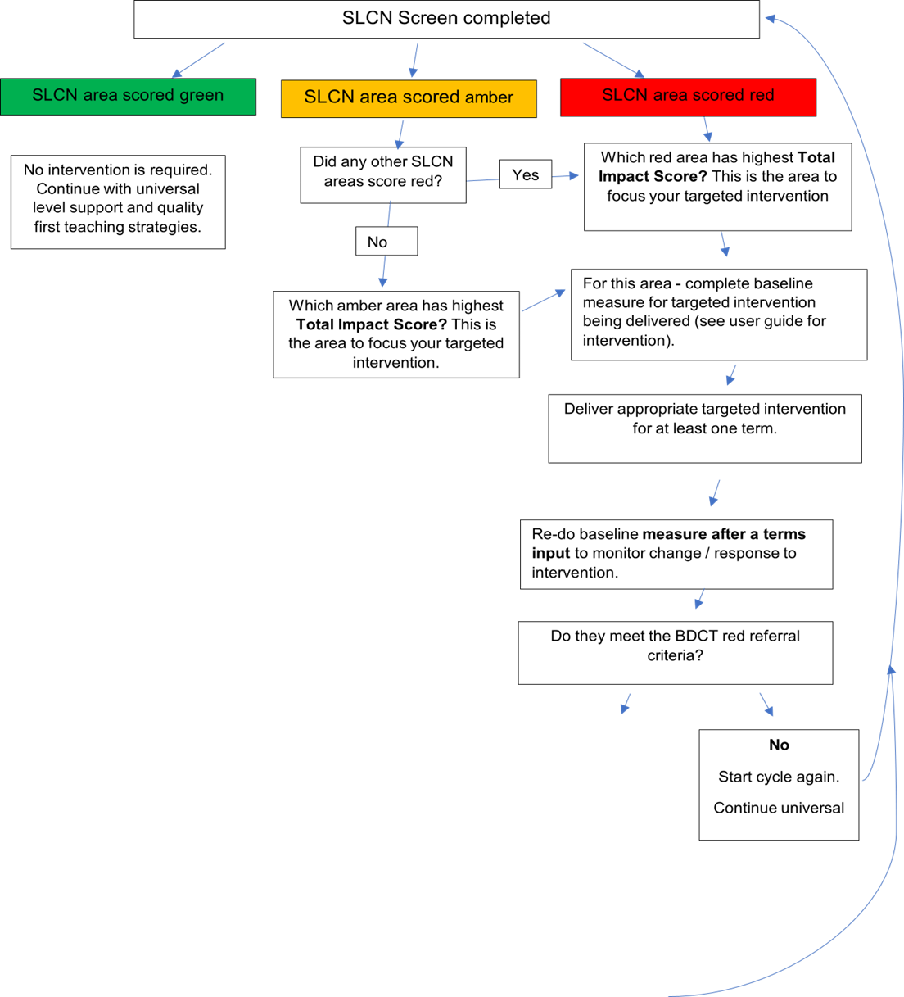
dDdo
Do they meet criteria for a SALT referral?
Yes
Make referral to SALT team. Include copy of:
- Information about the targeted intervention delivered (what and how much/ how long) and progress evidenced.
- Most recent screening results (can be Nottinghamshire SLT/R2i’s screen or a published resource e.g. Progression Tools, Wellcomm, etc… )
- Continue universal and targeted support whilst awaiting specialist support.

