Guide to Understanding Reading

What is Reading?
Reading is the ability to extract meaning from the text. To do this we need to understand individual words and then what a series of words mean when they are together with other words. In some reading situations we may need the whole sentence in order to understand the meaning of a word and subsequently how to pronounce it. For example, ‘The wind was blowing the trees’ vs ‘The clock wasn’t working so he needed to wind it up’. There are also times when we need to make links between two ideas or sentences to work out the hidden meaning, that is, to generate an inference.

Component skills of reading
There are six key factors that are important for successful reading: Motivation; pre-reading skills; decoding skills; language comprehension; fluency; and, executive functions.

- Motivation
Reading motivation refers to the student’s reason and drive to read. Motivation can impact on both how much a student reads and how they read. If a student has a strong motivation to read, then they will likely spend more time reading than a student who is not motivated to read. Additionally, compared to those students who are not motivated to read, those students who are motivated to read are more likely to try to understand the text and so more likely to use a wider range of comprehension skills (e.g. activation of background knowledge, inference generation). As a result, the motivated student will have more practice of their reading skills, particularly those higher-order reading skills, and so become better readers. The books that they are able to read and the enjoyment they get from reading will likely increase, which in turn serves to further increase reading motivation.

- Pre-Reading Skills
Pre-reading skills are early book handling and text identification and knowledge skills for example, being able to distinguish text from a picture, identify a single word and letter, book-handling skills, such as ability to hold a book, turn the pages, and know that we read from front to back and left-to-right.

- Decoding skills
The ability to recognise the basic sounds and sound blends, called phonemes, which make up a word. If the student cannot decode the words in a text, they will not be able to use their language comprehension skills to understand what they have read. The ability to successfully decode is underpinned by a student’s phonological awareness and letter knowledge:

Phonological Awareness
A phoneme is the smallest unit of sound. Phonological awareness is the ability to identify and manipulate these units of sound and is an umbrella term that covers a range of skills, which develop at different speeds; see Figure 2.

A student must have mastered the earlier skills before they can adequately master the later skills. For instance, if a student cannot identify a syllable, we cannot expect them to identify an individual phoneme and if a student cannot identify an individual phoneme, they will struggle to manipulate them.

Letter knowledge
Letter knowledge refers to a student’s ability to name letters and the sounds they make. This skill is essential for decoding, such that in reading the word ‘cat’, a student must be able to identify each individual letter and know what sound each letter makes in order to use their phonological awareness skills to blend the sounds together.

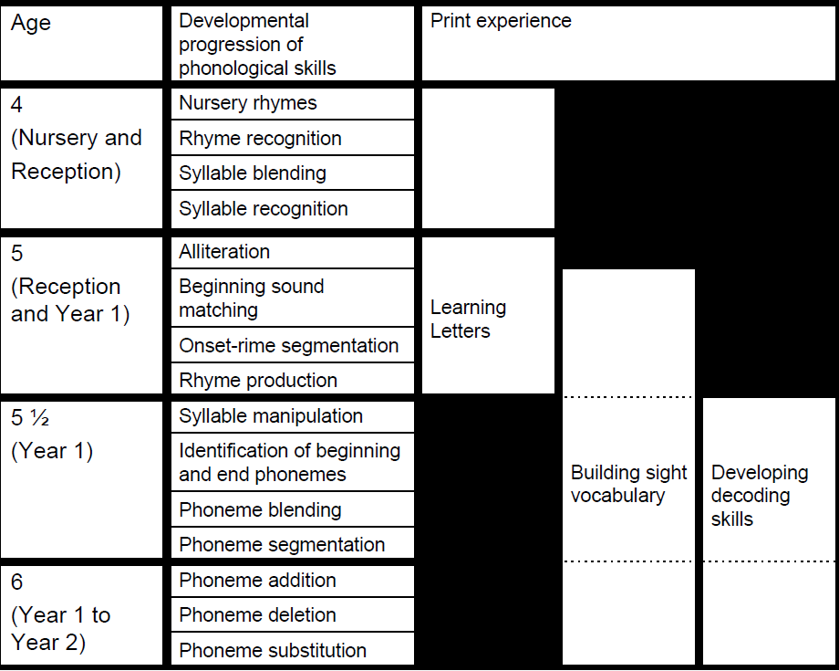
Figure 2. Developmental Progression of Phonological Awareness

- Language Comprehension.
The ability to understand a spoken or written sentence. Key component skills for effective language comprehension are given below:
Component Skill |  | Explanation
Vocabulary Knowledge |  | Vocabulary is the automatic activation of the meaning of a word. Vocabulary can vary in terms of breadth – i.e. how many words a student knows the meaning of – and depth – i.e. the extent to which a student can elaborate on the meaning of a particular word.
Activation of Background Knowledge |  | The activation of knowledge of an idea or topic from the student’s long-term memory. This knowledge may relate to personal experiences, things they have read or seen on the television, or information shared by the class teacher or other student.
Sentence Comprehension |  | The understanding of several words based on their word order. For example, ‘The cow was chased by the pig who was big’ has a different meaning to ‘The cow who was chasing the pig was big’. Sentence comprehension thus requires vocabulary and activation of background knowledge in addition to knowledge of grammar (i.e. word order).
Inference generation |  | Inference generation is the ability to link ideas together. There are many types of inference. Some are simple and develop early, for example the ability to link the word ‘cat’ with the word ‘it’ in this sentence: ‘The cat ran into the road, it was nearly run over’. Some inferences are a bit more complex and require the reader to activate their own knowledge to make a link between two ideas. For example, the reader must infer that the seed grew into the flower in the following sentence: ‘A man planted a seed, a week later there was a beautiful flower’.  The reader can make inferences about the characters’ motivations, actions, goals, emotions, intentions as well as inferences about the type of objects used (e.g. infer that if a man is sweeping, he is using a broom). A reader can also make inferences about the whole text, thinking about the moral or overall message a story.

- Fluency

The ability to read with accuracy using an appropriate pace and tone. If a student is reading slowly (i.e. less than one word per second) because their decoding skills are not yet automatic or they are struggling to process the language, it is unlikely that they will understand what they have read. Additionally, if a student does not understand how to use punctuation, this may impact on how they read and understand the text.

- Executive Functions/Cognitive Processes
Working memory. In the early stages of reading, working memory is needed to hold the letter sounds at the start of the word as the reader continues to decode the rest of the word. Working memory is also needed for the reader to hold the information they are reading/have just read, along with the vocabulary and background knowledge that has been activated from long-term memory.

Inhibitory control this skill is necessary for the reader to inhibit related background knowledge that is not necessary to understand the text.

Cognitive Flexibility. A student with limited cognitive flexibility may struggle to attend to the letters long enough to distinguish between visually similar letters (e.g. P and R). They may also struggle to learn irregular word patterns or digraphs (two consonants together or a vowel and consonant combination pronounced as a single sound) with multiple associated sounds, because they can find it difficult to shift between the different representations. For instance, ‘ow’ as in cow and ‘ow’ as in know. Cognitive flexibility is also needed to understand idioms (e.g. ‘it’s raining cats and dogs’), due to the student needing to flexibly move from a literal meaning to the intended meaning.

See next page for graphical representation of key component skills for reading

R2i Summary of component areas of reading

Domain knowledge for reading
- Pre-reading skills
- Decoding skills (Phonological Awareness, and Letter Knowledge)
- Language Comprehension
- Fluency

Motivation for Reading
- Reading motivation – what is driving me to do this?
- Reading goals and purposes - why am I reading this text?
- Reading self-efficacy – am I a good reader?
- Reading Engagement
Executive Functions for reading
- Working Memory
- Inhibitory Control
- Cognitive Flexibility
- Meta-reading skills* (e.g. did what I read make sense, do I need to go back and read it, did I just learn the meaning of a new word?)

