Maths Guidelines – How to use the resources

Introduction
You have come to this section because you feel that the young person is experiencing maths difficulties. In this section we will outline what Maths is and the core component skills that underpin maths ability. We then introduce the assessment of these underpinning skills to help you to explore the young person’s areas of strength and needs. Finally, we provide a helpful intervention pack to provide ideas around the strategies and support you may want to put in place based on your analysis.

What is Maths?
Maths competence relies on a complex interplay of multiple skill areas. Where there are difficulties in aspects of these skill areas, children can struggle to achieve at maths, and motivation can start to decrease. Therefore it is essential that the core underpinning skills are secure, and that, where difficulties exist, an in-depth understanding is obtained about the nature and root of any difficulty.

Domain skills and knowledge
Mathematical performance is made up of three broad skills areas as given below; for in-depth explanation of each area, see ‘R2i Guide to Understanding Maths’

- Concept. This is ‘Number sense’ which is the basic understanding of the concept of number; it includes: counting skills, numerical language, and relationships between numbers (including understanding patterns and sequences). This underpins the development of problem-solving skills and the use of mathematical operations and procedures.

- Procedure. This is the ability to use learnt mathematical knowledge:
  - Retrieval and use of arithmetic facts from long term memory.
  - Understanding and execution of learnt procedures for solving arithmetical problems.

- Language. Learning and using mathematical vocabulary and language. This includes learning and understanding the language for signs, symbols and shapes.

Cognitive Processes
The skills areas above rely on, and link to, key cognitive skills and processes, i.e.:
- Executive functions. All three components of the executive functions are fundamental to effective maths performance, i.e. working memory, inhibitory control, and cognitive flexibility.
In addition to:
- Processing skills including visual spatial processing skills, and especially in relation to Space, shape, and measure.

Other important cognitive processes for maths competence, include:
Memory skills (i.e. short-term and long-term memory); reasoning skills (such as sequential and logical thinking); and Problem-solving skills.

Motivation
Being motivated to learn is key for being engaged in the learning area. Motivation arises from successful experiences of the learning areas which leads to consequent self-efficacy for maths, see below for further explanation.

How we assess Maths
The assessments provided here enable the user to focus in on the young person’s key strength and difficulties in the underpinning component maths skills. First, print off the ‘R2i Maths skills Assessment Results Summary Sheet’ so that you can track progress of the assessments. Motivation and strong number sense (concept) will underpin maths performance, so these should be done first. For the last three assessments, you may need to do all of these, or may focus on one if there is a suspected difficulty around, for example, Maths language. N.B. For each of the Maths skill assessments we have created associated resource packs to support their use – these are found on the R2i Website after the associated assessment.

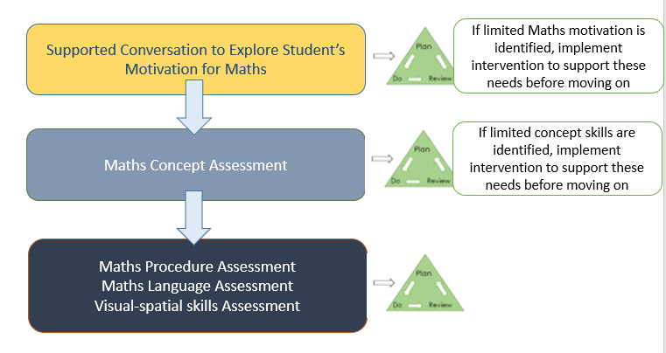

Plan, Do, Review
Once you have reviewed and analysed the assessment data and developed ideas of what component skills the young person needs support in developing, you can review the strategy list at the end of each assessment to select relevant strategies. The identified targets and chosen strategies should then be added to the ‘R2I Plan-do-review Target Tracker Template’ so that progress and outcomes can be tracked.

Links to additional resources
Numeracy probes / assessment
National centre for excellence in teaching Maths
https://nrich.maths.org/frontpage
https://www.nationalnumeracy.org.uk/essentials-numeracy

Summary of Component Skills of Maths
Domain skills for Maths
- Concept
- Magnitude
- Meaning/Counting
- Referents
- ‘More’ or ‘less’ comparisons
- Relationships

- Procedure.
- Use of knowledge of mathematical operations

- Language.
- Read & write numbers
- Sign & symbol recognition
- Language in context of maths

Cognitive processes for Maths

- Executive functions
- Visuospatial processing of space, shape and measure
- Memory
- Reasoning skills
- Problem solving skills

Motivation for Maths, arises from:

- Being comfortable with number and willing to solve problems with number and data
- Self-efficacy and self-confidence in relation to maths
- Successful and positive experiences of maths learning

