Assessment name | How it works |  | What it can tell you
SLCN Age-Specific screener  KS3/4 11y+ | This screening tool is for use with children aged 11+ years to find out what support you can give the child in your setting.  It is also designed to support you in deciding when you need to refer to the Speech and Language Therapy service (SLT). This is based on the service’s referral criteria found here on our website: https://www.nottinghamshirehealthcare.nhs.uk/slt-how-to-refer  Please base your answers on the child’s first (strongest) language. The child should only be referred to SLT if he/she has difficulties in his/her first language. When assessing a child with English as an additional language, please bear in mind:  It can take up to 2 years for a child to acquire a good level of conversational ability in their second language.  It can take 5-7 years for the child to use the second language to process learning tasks in the same way as they would use their first language. |  | Children who score amber will require support with their speech and language development. You should look for advice on universal strategies and targeted interventions found here on our website:  Children who score red will require support with their speech and language development. You should look for advice on universal strategies and targeted interventions found here on our website: https://www.nottinghamshirehealthcare.nhs.uk/cslt-support-and-advice  Refer to speech therapy (use our criteria checklist) if a child scores red in any of these areas:  - Vocabulary and word finding  - Spoken Language  - Speech sounds  - Stammering and voice  They may also score red in other sections too.  Continue to implement interventions in the padlet whilst the child is waiting to be seen by speech therapy.  Implement advice in the padlet for those scoring red ONLY in:  - Attention and listening and/or  - Understanding  Reconsider needs after this and if a referral is needed.  If a child scores red in the play and interaction section only, discuss with the SENCO if there are wider social communication needs and liaise with the specialist teacher team. This means that children who are verbally able but have some social communication needs may not meet speech and language therapy criteria at this point but will still require some support.
Child’s Name: |  | DOB: |  | Date Completed:
School: |  |  | Completed By:
Complete these tasks with the Student: | Notes/Observations
Have a conversation with the student. Ask them about their friends, what they like to do at home or what they did in the holidays or at the weekend. What do you notice? Can they answer your questions? Can you easily follow what they tell you? Does their language easily flow or is it effortful? Do they use complex sentences? Can they easily think of the words they need to express their ideas?
You may wish to use a recording device (e.g. ipad) to help you.
Ask the student to give you their opinion on something (choose a relevant topic from recent news events or the curriculum). What do you notice? You may wish to use a recording device (e.g. ipad) to help you.
Look at a familiar text with the student. Ask them questions about the text that involve reasoning and problem solving. Write down what you notice. You may wish to use a recording device (e.g. ipad) to help you.
Observe the YP while the class teacher is talking. What do you notice? Do they follow explanations and instructions? Do they look round to see what other people are doing? Do they wait to be prompted? Do they ask for help or clarification?

Screener Scores 7+ Years
- Social Communication the young person can: |  |  |  |  |  |  | Score: Yes = 1 No = 0
- Talk, listen, and respond in two way and group conversations.
- Use language to negotiate with others,
- Join in group conversations and maintain conversations to meet social needs.
- Understand and talk about how they and others are feeling.
Social Interaction: Total score
Circle R,A,G according to their score à |  | Red |  | Amber |  |  | Green
 |  | 0-3 |  | N/A |  |  | 4
- Understanding and Processing Language the young person can: |  |  |  |  |  |  | Score: Yes = 1 No = 0
- Understand classroom instructions and explanations.
- Show that they are aware when they don’t understand and ask for help when they have not understood.
- Infer meaning, reason, and problem solve.
Understanding: total score
Circle R,A,G according to their score à |  | Red |  | Amber |  |  | Green
 |  | 0-2 |  | N/A |  |  | 3
- Using Language the young person can: |  |  |  |  |  |  | Score: Yes = 1 No = 0
- Tell stories about their own experiences in a clear order, adding/leaving out information depending on how much the listener already knows.
- Explain their opinions and ideas and adults can easily follow their sequence of thoughts.
- Engage in conversations with others.
- Use complex grammar and vocabulary to communicate effectively.
Using Language: total score
Circle R,A,G according to their score à |  | Red |  | Amber |  |  | Green
 |  | 0-3 |  | N/A |  |  | 4
- Vocabulary and Word Finding the child can: |  |  |  |  |  |  | Score: Yes = 1 No = 0
- Use specific names for objects and people during conversation.
- Express ideas with minimal hesitation or pauses when speaking.
- Name objects directly rather than relying on descriptions or gestures.
- Persist in communication attempts, even when a word is hard to retrieve.
- Generate a range of words when asked to name items in a category (e.g., animals, foods).
- Retain new vocabulary taught and apply it to learning
- Understand a range of words to describe time, shape and texture.
- Recognise what sound a word starts with and can break words down into syllables
Vocabulary and Word Finding: total score
Circle R,A,G according to their score à |  | Red |  | Amber |  |  | Green
 |  | 0-3 |  | 4-5 |  |  | 6-8
  - Speech sounds – please complete the BDCFT speech sound screen - the young person can: |  |  |  |  |  |  | Score: Yes = 1 No = 0
- In conversation, familiar and unfamiliar staff always understand what the young person is saying.
- Is the following statement is true “The young person is not bothered by or upset by their speech sound difficulties”.
- The young person uses all the speech sounds in their language accurately and with confidence, including later developing cluster sounds such as ‘skw’ in squirrel, st, pl, pr, sl, sp, sn, sm,
- The young person can consistently articulate multisyllabic words confidently e.g. radiator, tripod, argument, helicopter.
Speech Sounds: total score
Circle R,A,G according to their score à |  | Red |  | Amber |  |  | Green
 |  | 0-2 |  | 3 |  |  | 4
- Other (including stammering and voice) |  |  |  |  | Score: Yes = 1 No = 0
The child’s talking is fluent and smooth when they speak.
The child can use words and sentences confidently and is not avoiding words or speaking situations
The child is showing no evidence of a stammer such as repeating parts or whole words, or showing a struggle or tension when they talk
Voice is clear, with no evidence of pain or strain when talking, or raspy sound.
Stammering: total score
Circle R,A,G according to their score à  Any score less than 4is an immediate referral to SALT | Red |  | Amber |  |  | Green
 |  |  |  |  |  | 4

SLCN Area | RAG Rating |  |  | Impact Rating |  |  |  |  |  |  | Total Impact Score
 | Tick the RAG rating from screening results for each SLCN area. |  |  | Ask the question “How much does the child’s difficulty negatively impact their a) learning b) interaction and friendships c) happiness and wellbeing?”  Using the following scale: |  |  |  |  |  |  | (Add impact score of a, b and c to create total per SLCN area)
 |  |  |  |  |  |  |  |  |  | 
 |  |  |  | No impact | Minor |  | Moderate | Major |  | Severe
 |  |  |  | 0 | 1 |  | 2 | 3 |  | 4
 |  |  |  | Write the numbers in the boxes below:
 | Red | Amber | Green | A |  | B |  |  | C |  | Total Impact Score
 |  |  |  | Learning |  | Interaction & friendships |  |  | Happiness and wellbeing |  | Total Impact Score
- Social Communication
- Understanding and Processing Language
- Using Language
- Vocabulary and Word Finding
- Speech sounds
- Other

Next Steps
Red | If more than one area scored red, use the Total Impact Score to guide the primary focus of targeted intervention i.e., whichever red SLCN area has the highest impact score - focus targeted intervention on that area. | https://www.nottinghamshirehealthcare.nhs.uk/download/slt-referral-checklist-april-2024.doc?ver=28027&doc=docm93jijm4n4248.doc  https://www.nottinghamshirehealthcare.nhs.uk/download/slt-referral-form-2024.docx?ver=28026&doc=docm93jijm4n4627.docx  - Complete baseline measure (the targeted intervention will usually include one).  - Deliver appropriate targeted intervention.  - Re-do baseline measure after a term’s input to monitor response to intervention.  - Consider, do they now meet the Nottinghamshire SALT RED referral criteria? If yes – consider the impact of the SLCN. If the impact is moderate - severe make a referral to SALT team. Include details of your screening results and targeted interventions with your referral.
Amber | If there are no Red areas, and more than one area scored Amber, use the Total Impact Score to guide the primary focus of targeted intervention i.e. whichever Amber SLCN area has the highest impact score, provide targeted intervention for this. Follow the same steps as detailed above, however, referral to the SALT service is not indicated.
Green | No intervention required. QFT

Name of child/ young person (CYP): |  | Class: |  | REVIEW DATE:
Immediate Referral to SALT Required  (alongside targeted intervention) |  | YES | NO
Review targeted Intervention before deciding A SALT Referral is Required |  | YES | NO
NO SALT Referral Required |  | YES | NO
Area targeted for development | Intervention / strategy | Rate  Effectiveness of intervention  0-5  0= no impact  5=full impact |  | Progress made at review date/ comments
1.

2.

3.

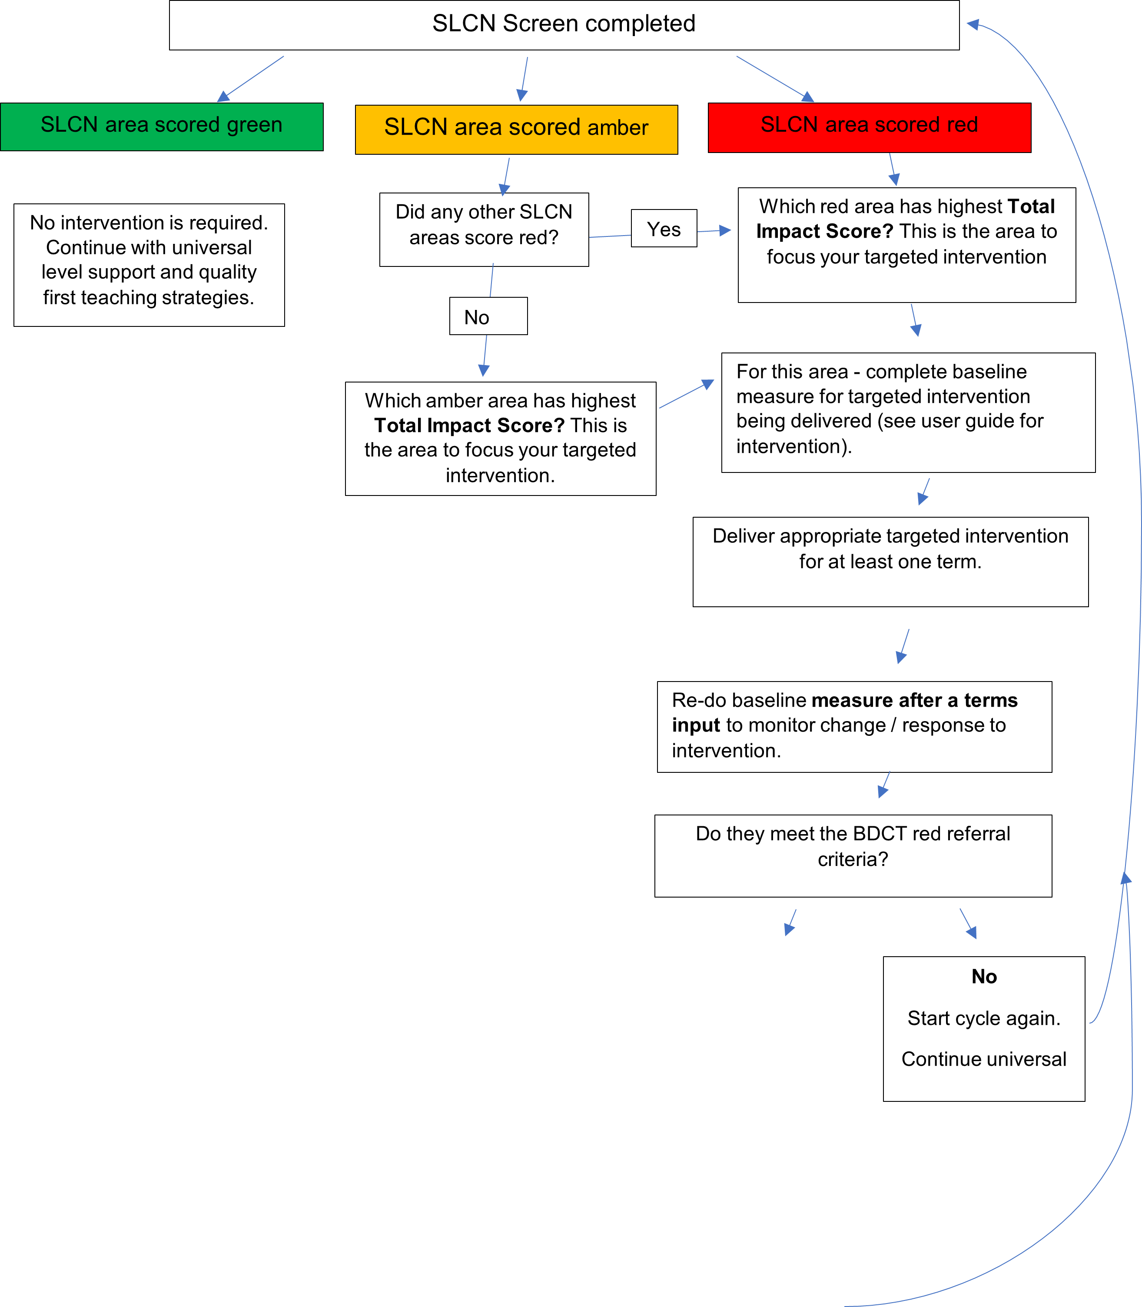
Yes
Make referral to SALT team. Include copy of:
- Information about the targeted intervention delivered (what and how much/ how long) and progress evidenced.
- Most recent screening results (can be Nottinghamshire SLT/R2i’s screen or a published resource e.g. Progression Tools, Wellcomm, etc… )
- Continue universal and targeted support whilst awaiting specialist support.

Do they meet criteria for a SALT referral?
dDdo

