Reading Guidelines – How to use the resources

Introduction
You have come to this section because based on the initial concerns checklist you feel that the student is experiencing reading difficulties. In this section we will explore what reading is and those skills and sub-components that underpin successful reading. We will then guide you through an assessment of these underpinning skills and subcomponents to help you to explore the student’s areas of strength and needs. Finally, we provide a helpful intervention pack to provide ideas around the strategies and support you may want to put in place based on your analysis.

What is Reading?
Reading is the ability to extract meaning from the text. To do this we need to understand individual words and then what a series of words mean when they are together with other words. In some reading situations we may need the whole sentence in order to understand the meaning of a word and subsequently how to pronounce it. For example, ‘The wind was blowing the trees’ vs ‘The clock wasn’t working so he needed to wind it up’. There are also times when we need to make links between two ideas or sentences to work out the hidden meaning, that is, to generate an inference. (we have provided a reading guide to aid your understanding of reading development – link here).

Successful reading then is complex and dependent on many skills. It can be helpful to think of successful reading comprehension as a house – see image below. In our model, reading comprehension is the roof, but to achieve this goal 3 key blocks are needed: Word reading skills, language comprehension skills, and reading motivation. Each of these blocks is made up of smaller bricks, which we explore in more detail shortly.

And of course, before we can start building the house a firm foundation is needed. In reading a firm foundation requires pre-reading skills and executive functions.

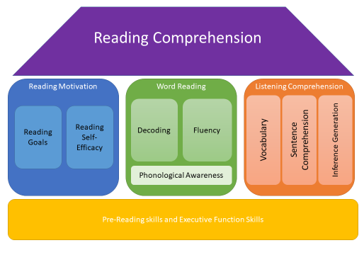

How do we assess reading?
We are assessing the component skills underpinning reading comprehension (i.e. decoding and language comprehension) rather than a direct assessment of reading comprehension.

If we look at the reading house, gaps in any of the underpinning blocks will mean that the house is unstable – i.e. gaps in any underpinning skills means that the child will struggle to fully understand and extract meaning from texts presented to them.

A rocky foundation will mean that it is difficult for the child to build, develop and utilize new skills built on top. For instance, a student may have the reading skills (decoding skills) needed to read a text, however, they may not successfully use these skills if they experience difficulties with the cognitive processes needed to do so. This is why we encourage you to explore the student’s executive functions using the assessment accessed here.

Similarly, gaps in the blocks mean that the roof will be wobbly – i.e. reading comprehension will not be complete. For instance, a student may have the reading skills needed to successfully engage with a text, but not be motivated to do so. You may also meet pupils who can read the words on the page, but lack oral language skills and so do not understand what they have just read to you.

We thus recommend you follow the assessment pathway below. Please remember that assessment Stage 1 of the assessment toolkit should be completed first. Printing off the reading skills assessment and results summary sheet will help you to track the progress of the assessments you’ve completed.

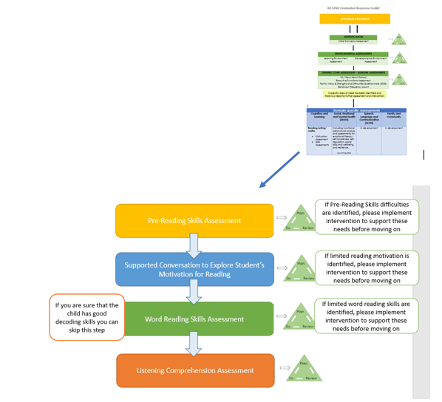

General guidelines for using the resources
The reading toolkit has been designed to help you to identify any gaps in those skills and components underpinning reading comprehension. To make the best use of the reading toolkit we recommend you:
- Complete the initial SEND assessments (see process flow for the initial green assessments) before you start the reading toolkit.
- Follow the process flow to ensure that pre-requisite reading skills are in place before addressing the more complex skills. We want young people to have a firm foundation upon which to grow their reading skills. There is no expectation that you complete all the assessments, only that you work through the process flow in the order presented so that you can identify underpinning needs. We also recommend that assessments findings are used to underpin a plan do review cycle, meaning that a young person would not generally complete more than two of the assessments within a half term.
- Adopt a collaborative approach, involving the young person’s teaching team in assessment, analysis, and planning. We recognise that this requires a time commitment from both yourself and the young person’s teaching team, but we hope that this time will allow a full and detailed picture of the young person’s reading skills to be developed, which will subsequently inform the creation of specific and effective intervention. We hope, then, that this will result in time saved in the long run.
- When administering the assessments do not provide the answers or details of if correct or not as you may use the assessments at a later date, instead you can respond with ‘Well done’ or ‘Thank you’ to the young person’s responses.
- Adapt the administration of test materials based on your professional judgement. You know your young people best. You know how long they can sit and concentrate for; you know how much they can process and understand. Therefore, we advise that the assessments are used as a guide, with the administration tailored to individual needs.
- This toolkit is used when your school data/standardized reading assessments have flagged up an issue with reading. We do not expect that this toolkit is used with every young person in your school.

We would like to assure you that this toolkit has been designed to support you. It is in no way a requirement to accessing support services. If you find an area of need, implement intervention and the child makes good progress it is ok to stop there. You do not have to complete all assessments.

Plan, Do, Review
Once you have reviewed and analysed the assessment data and developed ideas of what component skills the young person needs support in developing, you can access the reading intervention’ pack to choose relevant strategies. The identified targets and chosen strategies should then be added to the ‘R2I Plan-do-review Target Tracker Template’ so that progress and outcomes can be tracked.

Links to additional resources
- Precision Teaching ‘placement probes’ can be used to get a baseline for reading ability
- Online and purchasable reading assessments
- Literacy programmes
- Staffordshire CC Reading accuracy, fluency and generalisation assessment:
This assessment is helpful to understand more about the young person’s decoding skills in terms of letters, sounds, and words they are able to read/decode

