Steps to learning to say a sound
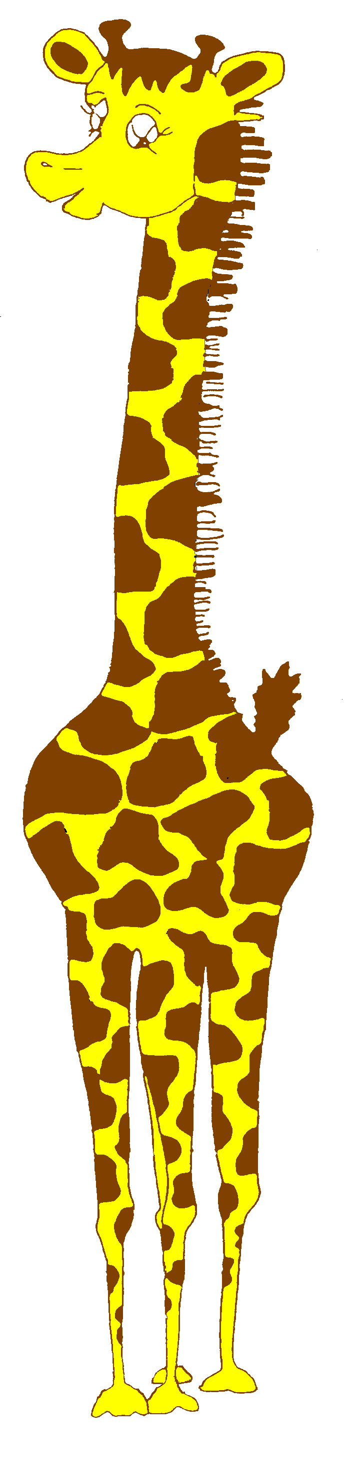
When ____________has achieved 90% success at one level, move on to the next level.

14 | Using the sound in conversation.
13 | Saying the sound when talking about pictures, telling stories, special talking times.
12 | Saying the sound in several words in a sentence.
11 | Saying the sound in words in sentences by yourself.
10 | Saying the sound in words in sentences after someone else.
9 | Saying the sound in words in phrases by yourself
8 | Saying the sound in words in phrases after someone else.
7 | Saying the sound in words by yourself.
6 | Saying the sound in words after someone else has said them.
5 | Saying the sound in silly words (sound with a vowel).
4  3  2 | Saying the sound by itself  Hearing and identifying the sound at the start/end of words  Hearing and identifying the sound at the start/end of silly words (sound with a vowel)
1 | Hearing and identifying sounds that adults use

