Story Board
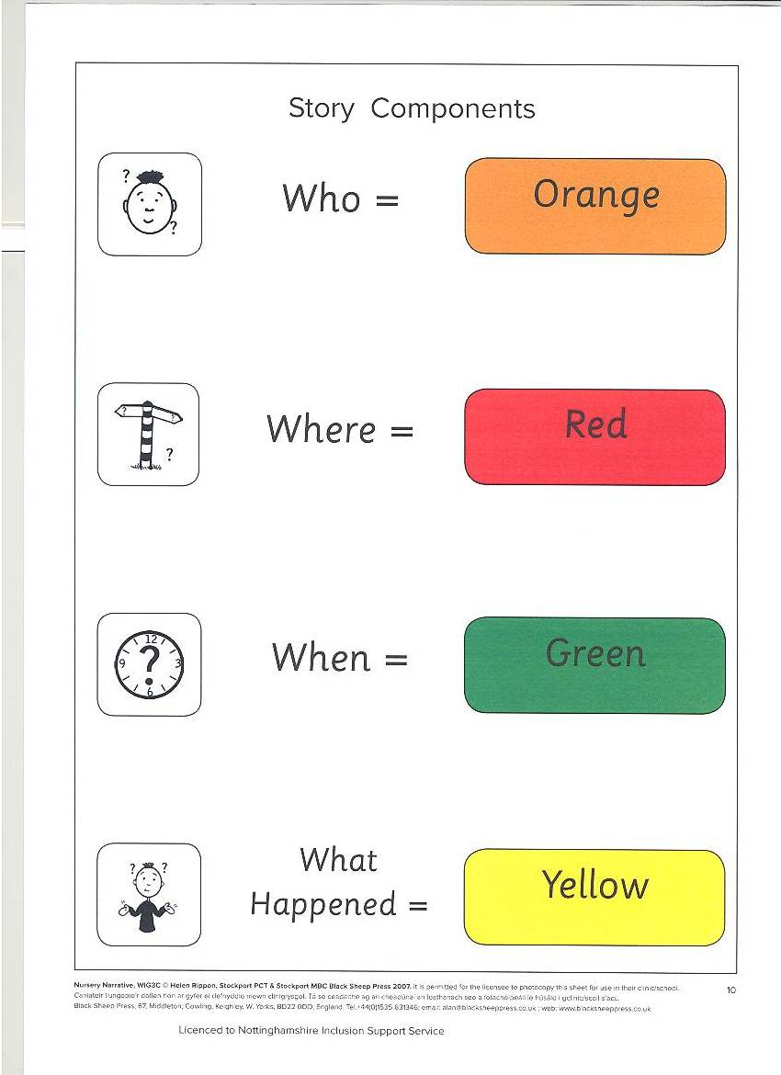
Who ?

Where ?

When ?

What
happened ?

