WORD WHEELS

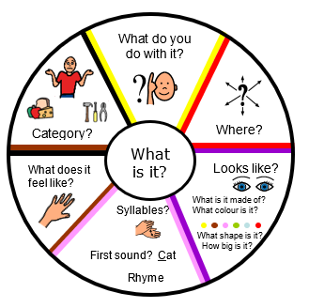
How do word wheels help?

- They help children to organise the words that they already have stored in their heads.
- Better organisation of words means that children can
  - store more words
  - access words more easily
  - learn new vocabulary more easily
- When familiar with using word wheels, they can also be used to learn new words.

Research suggests that focussing on ‘word meanings’ (semantics) helps children to effectively learn and store vocabulary.
We also know that learning about the ‘patterns of sounds’ (phonology) in words helps children to learn and store new words. However, many children with SLCN find phonological awareness tasks very difficult. Adults should be aware of this and provide additional support where needed.
If the child you are working with is finding the ‘phonology’ questions difficult you could:
- Try completing some of the activities in the Phonological Awareness Activity Pack (in the Speech section of the R2i padlet).
- Focus on the questions that explore word meanings.

How to use a word wheel:
Place a picture or an object in the middle of the wheel. The child should be able to name it. Explore the word using the questions as a guide. The questions encourage the child to think about 1) word meaning (semantics) and 2) the patterns of sounds in the word (phonology).

Questions that encourage the child to think about word meaning (semantics):
- Function: ‘What do we do with it?’, ‘What do we use if for?’
Ask the child what we do with the item, accept their answers but feel free to talk about more appropriate uses if they don't give the expected use. At this stage decide to either go through lots of items, naming and giving function only or go round each spoke in turn for each item. With older children I tend to go all round for each item.
- Location: ‘Where do we find it?’
Ask the child where it is found. Here you are looking for the most common place. If the child does not say what you expect you can always discuss alternatives.
- Category: ‘What group does it belong to?’
Ask the child what group it belongs to. They may give a category name, e.g.: clothes, transport; or they may describe its function, e.g.: 'to wear', 'for travelling' etc. These are acceptable, you could give them the category name as well, but they may not use it for some time.
- Senses: ‘What does it look like?’, ‘How does it feel, smell, taste?’
Talk about what it is like, e.g.: hard/soft, rough/smooth, etc. See if the child can give you some more examples of things that are hard/ soft, etc. This strengthens the links between the words and helps access. Talk about the parts of the object, e.g. buttons, legs, windows, etc. Talk about what other objects have these parts. This again helps to strengthen the link between words and so ease retrieval. Encourage the child to think widely, e.g.: buttons on a coat, remote control, chocolate sweets, etc.

Questions that encourage the child to think about patterns of sounds (phonology):
- Sounds and syllables: ‘What sounds does it start with?’
Ask the child to clap the syllables in the word. These are the smaller parts of a word; they usually have a vowel sound in them. Syllable awareness is important for reading and spelling. Can the child think of 2-5 other words with the same number of syllables?

- Rhyme: ‘What words sound the same?’
Ask the child to give you 2-5 examples of words that rhyme with the target word. Rhyme awareness is important in learning to spell; it reduces the load on the child's memory. Ask the child to tell you what sound the word starts with. Remember this should be sounds, not letter names. Can the child think of 2-5 examples of words starting with the same sound? It may help if the child thinks within groups of words, e.g.: animals beginning with -'d', etc.



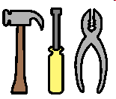
WORD WHEEL
Category?
Syllables?
First sound? Cat

Rhyme

What does it feel like?
What do you do with it?
Where?
Looks like?
What is it made of?
What colour is it?

What shape is it?
How big is it?
What
is it?

