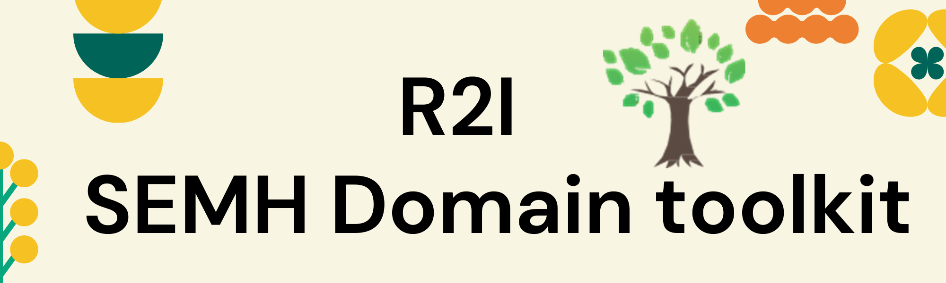
What’s Inside

SEMH Theory and definition | SEMH Universal Provision | Assessment Tools | Intervention | Signposting
 |  |  |  | 
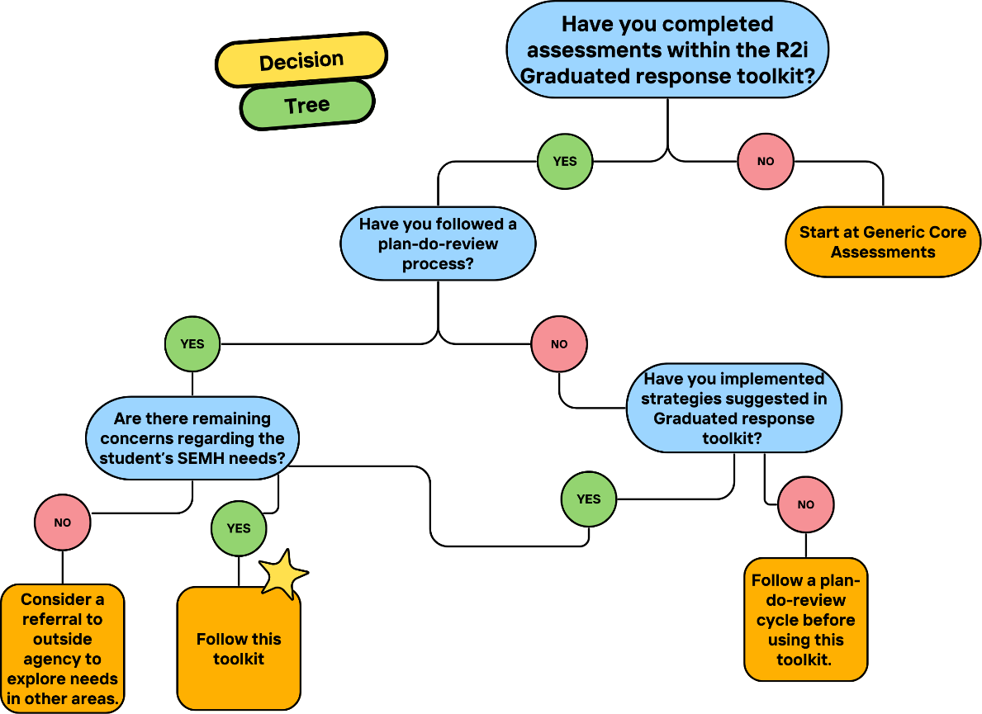
This toolkit is designed to further support your exploration of identified SEMH needs and match this effectively to intervention. This toolkit follows plan-do-review cycles using the R2i Graduated Response assessments and suggested strategies. The decision tree below will support your assessment of whether this toolkit is suitable for use at this time.

Purpose of Toolkit

 | Function | Teen Development
Prefrontal Cortex | Responsible for decision-making, impulse control, planning, and reasoning. | Still maturing during adolescence, leading to riskier behaviour and less foresight.
Limbic System | Processes emotions and rewards. | Develops earlier which can lead to heightened emotional responses and sensation-seeking behaviour.
Synaptic Pruning | Elimination of unused neural connections to increase brain efficiency | “Use it or lose it” principle—skills and habits practiced during adolescence are reinforced.
Myelination | Insulation of neural pathways with myelin to speed up communication. | Improves cognitive processing and coordination over time
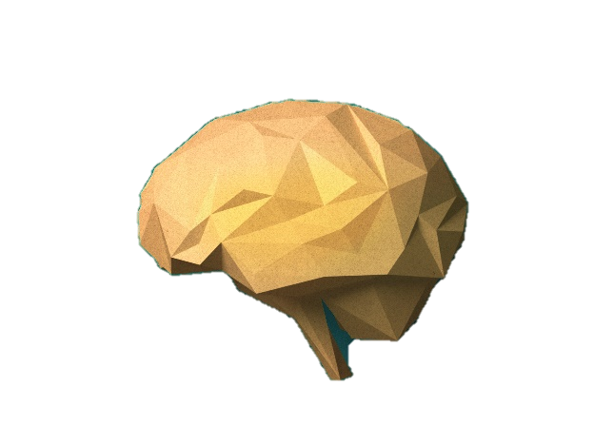
Key elements of Teen Development
SEMH Theory
The Adolescent Brain

Further reading:
Brainstorm by Daniel J. Siegel | Waterstones
Inventing Ourselves

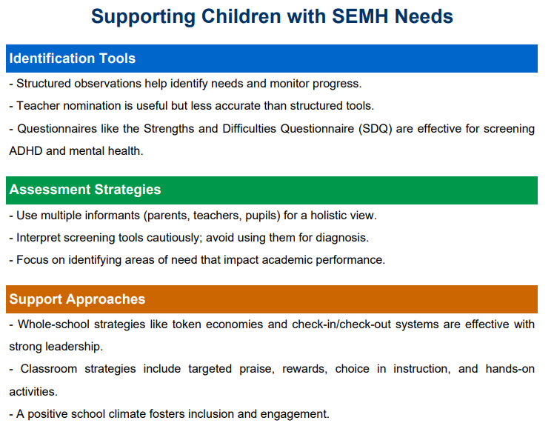
Identifying and supporting children and young people with social, emotional and mental health needs: a rapid evidence review Research report September 2025
DfE: Identifying and supporting children and young people with social, emotional and mental health needs: a rapid evidence review.
Research report September 2025
SEMH Research

The difficulty in providing an absolute definition of SEMH needs is reflective of the diverse range of issues relating to presentation, assessment and prevention.
SEMH Definition
With consideration of existing research we have devised the following as a way of conceptualising SEMH needs for the purposes of this toolkit:
Social | Social development refers to how well you interact with others and form meaningful relationships.
Social | Communication Skills: Being able to express yourself clearly and listen to others.
Social | Friendships: Building and maintaining positive relationships with peers.
Social | Teamwork: Working well with others in group settings.
Social | Conflict Resolution: Handling disagreements in a healthy and constructive way.
Emotional | Emotional development is about understanding and managing your feelings.
Emotional | Self-Awareness: Recognising your own emotions and how they affect your behaviour.
Emotional | Self-Regulation: Being able to control your emotions and reactions, especially in stressful situations.
Emotional | Empathy: Understanding and sharing the feelings of others.
Emotional | Coping Skills: Finding healthy ways to deal with stress, sadness, or anger
Mental Health (Wellbeing) | Wellbeing involves your overall psychological well-being
Mental Health (Wellbeing) | Cognitive Functioning: How well you think, learn, and remember.
Mental Health (Wellbeing) | Resilience: Your ability to bounce back from setbacks and challenges.

Eight principles to promoting a whole school or college approach to mental health and wellbeing audit (DfE Promoting children and young people’s mental health and wellbeing. A whole school or college approach, Sept 2021). Online audit nationalwsa.com
SEMH Universal Provision
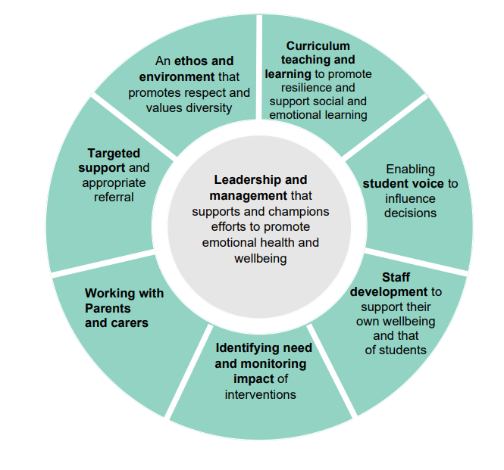
1.Leadership and Management
2.Curriculum and Teaching to Promote Resilience
3.Student Voice
4.School Staff
5.Parents and Carers
6.Recognising Mental Health Needs
7.Ethos and environment
8.Targeted Support

Social | Social development refers to how well you interact with others and form meaningful relationships.
Social | Communication Skills: Being able to express yourself clearly and listen to others.
Social | Friendships: Building and maintaining positive relationships with peers.
Social | Teamwork: Working well with others in group settings.
Social | Conflict Resolution: Handling disagreements in a healthy and constructive way.
Social Development
- Student Assessment
  - Student Questionnaire
  - Sort Card Alternative
    - Support with analysing the data
  - Scenario Assessment
    - Support with analysing the data
- School Staff Assessment
  - Short Questionnaire
- Home Assessment
  - Questionnaire covering all areas of SEMH
Intervention / Strategies
Universal:
- Restorative Conversations
- Comic Strip conversations
- Circle time
- Co-operative Learning
- Peer mentoring
Targeted:
- TalkAbout Social Communication intervention The Talkabout resources - TASS
- FRIENDS resilience programme Friends Resilience
Emotional Development
Emotional | Emotional development is about understanding and managing your feelings.
Emotional | Self-Awareness: Recognising your own emotions and how they affect your behaviour.
Emotional | Self-Regulation: Being able to control your emotions and reactions, especially in stressful situations.
Emotional | Empathy: Understanding and sharing the feelings of others.
Emotional | Coping Skills: Finding healthy ways to deal with stress, sadness, or anger
- Student Assessment
  - Card sort activity
- Staff Assessment
  - Functional Behavioural Analysis
- Home Assessment
  - Questionnaire covering all areas of SEMH
Intervention:
Universal:
- Emotion coaching
- Key adult check-in
- Relationship approaches
Targeted:
- SEAL resources SEAL+intro+booklet_Redacted.pdf
- CBT-based interventions:
  - Think Good, Feel Good Think Good - Feel Good : A Cognitive Behaviour Therapy Workbook for Children and Young People
  - Homunculi (PDF) The Homunculi: a flexible CBT approach to social and emotional wellbeing in children and adolescents on the autism spectrum
  - Feelings Detectives Introduction to Feelings Detectives — Feelings Casefiles
- ELSA educational-psychology-service-brochure.pdf

Mental Health (Wellbeing) | Mental health and wellbeing involves your overall psychological well-being
Mental Health (Wellbeing) | Cognitive Functioning: How well you think, learn, and remember.
Mental Health (Wellbeing) | Resilience: Your ability to bounce back from setbacks and challenges.
Mental Health

- Student Assessment:
  - Anna Freud Resilience Survey Student Resilience Survey
- Home Assessment/ Consultation.
  - Risk and Protective Factors

Intervention
- Universal
  - Senior Mental Health Leads (see MHST)
  - Trauma informed training (Can be provided by EPS and MHST)
  - Mentally Healthy Schools Anna Freud Toolkit for schools and colleges : Mentally Healthy Schools
  - Supervision for staff educational-psychology-service-brochure.pdf
- Peer Support Programme Peer Support Programmes for Mental Wellbeing in Schools & Colleges | Anna Freud
- Targeted: MHST (see signposting)

Child/Young Person’s Name: |  | School:
Age: |  | Staff Name(s):
Class: |  | Role(s):

SEMH Domain Summary Action Plan

Universal Provision
What have you implemented for universal provision for SEMH needs?
SEMH Focus and Assessments undertaken | Summary of Analysis  Eg Strengths  Needs  Hypothesis? | Actions/strategies/quick wins | Date to Action | Date to Review | Rate Effectiveness  0=no impact  5=full impact | Comments on Progress  Has the concern lessened/resolved/ongoing?  What are our next steps?  Why do we think this progress has or has not been made?

Signposting
Social | Healthy Relationships | Act On It Now ;Relationships | Health for Teens
Social | CSE | Child Sexual Exploitation & How to Keep Your Child Safe | NSPCC
Social | Online Safety | Keeping children safe online | NSPCC
Emotional | Educational Psychology Service | educational-psychology-service-brochure.pdf
Emotional | Free Resources | https://www.socialworkerstoolbox.com/emotional-well-being-pack-for-ages-13-18/ Emotion Exploration Worksheets for Teens | Therapist Aid
Emotional | Reading list | Books on wellbeing for teens | BookTrust
Mental health | NottAlone Website | Mental Health Support | NottAlone - Supporting Your Child
Mental health | Mental Health Support Team
Mental health | Mental Health services | nottingham-city-mental-health-services.pdf
Mental health | Student focused apps | Home page - Mindamigo; The Mix

