Writing Guidelines – How to use the resources

Introduction
You have come to this section because you feel that the young person is experiencing writing difficulties. In this section we outline what writing is and the sub-components skills that underpin successful writing. We then introduce the assessment of these underpinning skills to help you to explore the young person’s areas of strength and needs. Finally, we provide a helpful intervention pack to provide ideas around the strategies and support you may want to put in place based on your analysis.

What is Writing?
Writing is complex! First, the young person needs to generate an idea by activating knowledge from their long-term memory or their environment. Once they have an idea, they need to put it into words and then put these words into an order that makes sense. Then the young person needs to write these words down, drawing upon their spelling and handwriting skills as they progress.

The task of writing becomes more complex if the young person is writing more than one sentence due to needing to create coherence. This means that the sentence they are writing must make sense and in some way link to the sentence they have just written and/or are about to write next. This requires working memory skills, such that the young person must hold in mind: the sentence(s) they have written; the sentence they are currently writing; and the overall idea they are trying to convey. As the young person becomes more proficient, they also need to monitor and revise what they are writing as they go.

Writing then is a complex task, resulting from the interaction of many component skills - see image below. Therefore, if a young person is experiencing writing difficulties this could stem from needs in any one of these component skill areas. It is important to identify the specific area of need as this will inform the type of intervention required. In our model, 4 key skills are needed:

- Executive Functions
- Motivation
- Transcription skills (handwriting and spelling)
- Compositions Skills (vocabulary use, idea generation, sentence construction, creating coherence). See ‘R2i Guide to Understanding Writing’ for further explanation.

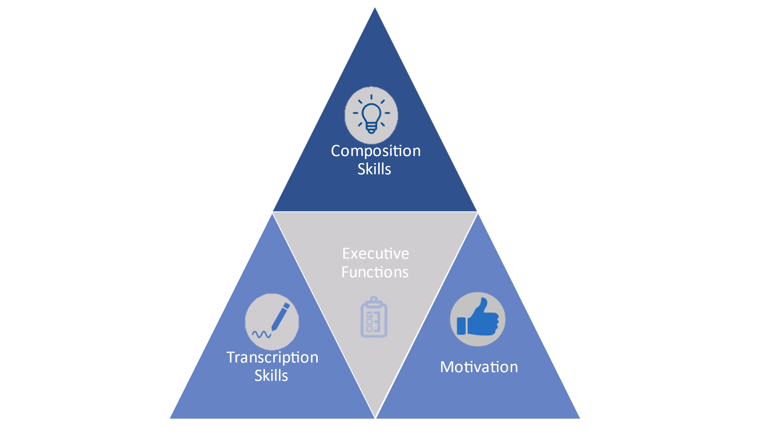
Figure 1. Visual Depiction of the Sub-Components of Writing

How do we assess writing?
We are assessing the component skills underpinning successful writing (i.e., executive functions, motivation, transcription skills, composition skills) rather than a direct assessment of writing.

If we look at Figure 1, difficulties in any of the sub-components of writing will mean that the writing pyramid will not be complete. Difficulties in transcription skills mean that cognitive effort must be focused on handwriting or spelling, leaving little cognitive capacity for the more complex composition skills. The child’s writing will thus be short, uninteresting and may not make sense. Similarly, if a child has difficulties with composition skills, they may try hard, and their work may be perfectly presented when they are copying text. However, they may produce very little when asked to write independently and their writing may make little sense. Additionally, a child may have good transcription and composition skills but not be motivated to write.

You will note that executive functions sit at the heart of the writing pyramid, this is due to their central role in the writing process, particularly as children are expected to write longer texts. Working memory is particularly important as the child must hold and manipulate large amounts of information when writing including sound-to-letter pairings, motor patterns needed to visually produce letters, what has already been written, what they are writing, what they plan to write next. If the child’s working memory capacity does not allow them to hold this information we will see spelling errors, messy handwriting, and texts that do not make sense. Additionally, children may have limited cognitive capacity left to engage in more complex writing skills that make texts interesting to read.
Executive functions are also fundamental to successful planning and editing, which, particularly in longer texts, are essential to the writing process. Therefore, limited executive functions may mean that children do not plan, check or edit their work.

We thus recommend you follow the assessment pathway below. Please remember that assessment Stage 1 of the assessment toolkit should be completed first. Printing off the writing skills assessment and results summary sheet will help you to track the progress of the assessments you’ve completed.

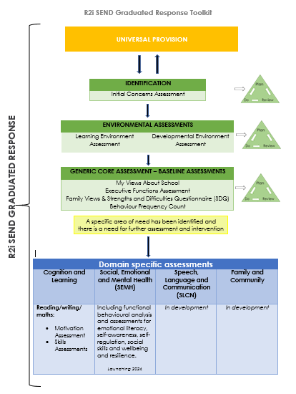

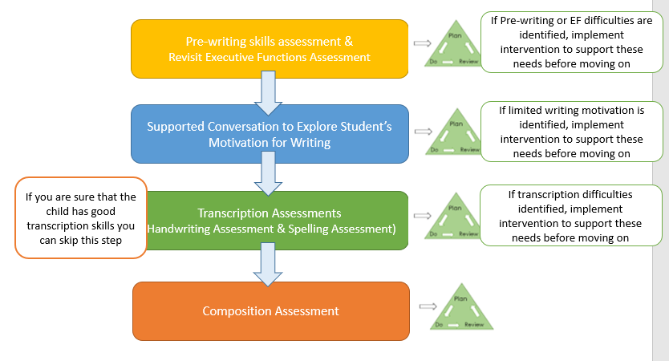

General guidelines for using the resources
The writing toolkit has been designed to help you to identify any gaps in those skills underpinning writing. To make the best use of the reading toolkit we recommend you:
- Complete the initial SEND assessments (see process flow for the initial green assessments) before you start the reading toolkit.
- Follow the process flow to ensure that pre-requisite writing skills are in place before addressing the more complex skills. We want young people to have a firm foundation upon which to grow their writing skills. There is no expectation that you complete all the assessments, only that you work through the process flow in the order presented so that you can identify underpinning needs. We also recommend that assessments findings are used to underpin a plan do review cycle, meaning that a young person would not generally complete more than two of the assessments within a half term.
- Adopt a collaborative approach, involving the young person’s teaching team in assessment, analysis, and planning. We recognise that this requires a time commitment from both yourself and the young person’s teaching team, but we hope that this time will allow a full and detailed picture of the young person’s writing skills to be developed, which will subsequently inform the creation of specific and effective intervention. We hope, then, that this will result in time saved in the long run.
- When administering the assessments do not provide the answers or details of if correct or not as you may use the assessments at a later date, instead you can respond with ‘Well done’ or ‘Thank you’ to the young person’s responses.
- Adapt the administration of test materials based on your professional judgement. You know your young people best. You know how long they can sit and concentrate for; you know how much they can process and understand. Therefore, we advise that the assessments are used as a guide, with the administration tailored to individual needs.
- This toolkit is used when your school data/standardized writing assessments have flagged up an issue with reading. We do not expect that this toolkit is used with every young person in your school.

We would like to assure you that this toolkit has been designed to support you. It is in no way a requirement to accessing support services. If you find an area of need, implement intervention and the child makes good progress it is ok to stop there. You do not have to complete all assessments.

Plan, Do, Review
Once you have reviewed and analysed the assessment data and developed ideas of what component skills the young person needs support in developing, you can access the writing intervention pack to choose relevant strategies. The identified targets and chosen strategies should then be added to the ‘R2I Plan-do-review Target Tracker Template’ so that progress and outcomes can be tracked.

Links to additional resources
Assessment of speed of handwriting
Henderley sentence completion test
Spelling Assessments

