Writing Conversation
CHILD VERSION
Young person’s name: |  | Date:
Assessor name: |  | School:

- View of school

What do you think of school?



What are you good at? What do you like doing?



What do you find tricky?

- View of Writing
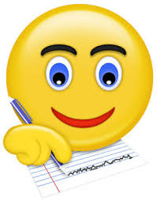
What is the best piece of writing you’ve ever done?

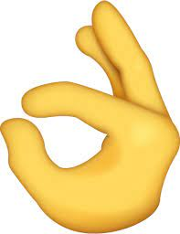

What do you like to write about most?



Do ever write for fun (e.g. write even when your teacher hasn’t asked you too – this could be in school or at home)?

- Writing differences
In which lessons/activities is writing…
 | …easier | …harder
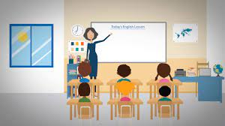

How do you feel about other children in your class seeing your writing?


How do you feel about your teacher or teaching assistant seeing your writing?

- Yourself as a writer
Think of a really good writer in your class. What things makes them a good writer?

If the good writer was on ‘10’ and a poorer writer on ‘1’, where would you put yourself?

Why there?

Where would you like to be, and what would help you move up?

- Strategies for Writing
What things help you when you are writing?
- Thinking about what you need to write and saying the sentence before writing it?
- Having a bank of words to help you to spell those tricky words?
- Something else?

Which helps the most?

Which helps the least?

What other help would you like in order to get better at writing?



