R2i
Speech, Language and Communication (SLCN) Toolkit

Aims
The aims of this document are to support Nottingham City staff working with children and young people who may have Speech, Language and Communication needs and to:
- Raise awareness of the different kinds of Language and Communication needs and the impact these can have on learning, social interaction, behaviour, and development.
- Provide clear expectations for schools and settings, and explain what intervention may be necessary in school when a child may have Language and Communication needs.
- Provide guidance on how to find out what parts of Language and Communication children are struggling with, and offering various forms of assessment.
- Suggesting interventions for a variety of difficulties.
- Providing guidance on how to monitor and record progress and target setting.
- Provide a wealth of information to support effective practice in using a graduated response and evidence based practice to meet needs in the area of language and communication. This reference material is located later in the pack for those wishing to know more.

Introduction and Rationale for the Speech, Language and Communication (SLCN) Toolkit: Understanding the Building Blocks of Communication

Supporting Early Detection of SLCN in Children
- Effective identification of Speech, Language, and Communication Needs (SLCN) in children is a critical first step in ensuring timely and appropriate support.
- This toolkit has been developed to guide teaching staff in recognising early signs of SLCN through a structured, evidence-informed approach that reflects current best practices in developmental and ecological models of communication.

Foundations First: Understanding the Precursors to Language
- At the heart of this toolkit is the understanding that communication does not develop in isolation.
- Instead, it emerges through a child’s interactions with their environment, caregivers, and peers.
- Models that prioritise foundational skills such as play, attention, and listening are central to this approach.
- These elements are not only precursors to language development but also indicators of how a child engages with the world around them.
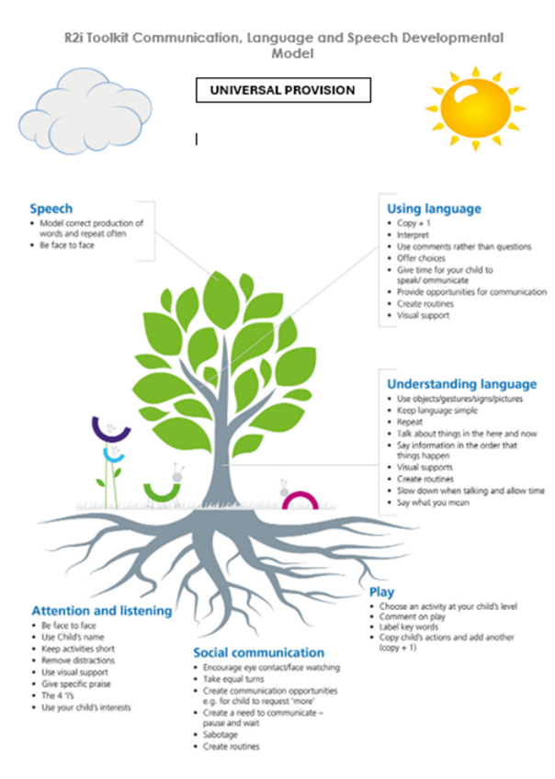
A Holistic Approach: Principles Guiding the SLCN Toolkit
The structure of this toolkit is grounded in the Social (Participative) Model of Disability, as endorsed by the Royal College of Speech and Language Therapists.

This model represents a shift from viewing communication difficulties as deficits within the child, to understanding them as the result of a dynamic interaction between the child and their environment.

It encourages a more inclusive and holistic perspective, which is reflected in the toolkit’s design and application.

Key principles underpinning this toolkit include:
- Inclusive Communication Practices: Encouraging the use of strategies that support all learners, not just those with identified needs.
- Empowerment of Educators and Families: Providing practical tools and shared language to help adults identify and respond to communication challenges confidently.
- Environmental Adaptation: Highlighting the importance of modifying classroom and social settings to reduce barriers and enhance communication opportunities.
- By embedding these principles, the toolkit aims to support early identification and intervention, promote inclusive education, and foster collaborative working between educators, families, and specialists. It is not just a diagnostic aid, but a resource for reflection, observation, and responsive teaching.

Vital importance of Speech, Language and Communication skills
Language skills are essential for learning and social interaction and development.
They are essential for learning to read, to socialise, to express needs and gaining the emotional help and support that children require throughout the day.
The Communication Trust (*1) reports that over 1 million children have some form of persistent speech, language and communication difficulty, which equates to roughly 2 or 3 children in every classroom in the UK.
In areas of poverty, children enter school with roughly 50% less vocabulary than in other areas, but many of these children can catch up with the right support, and with language-rich environments.
The Communication Trust reports that:
- 50-90% of children with persistent speech, language and communication difficulties go on to have reading difficulties.
- Two thirds of 7 -14 year olds with serious behaviour problems have some form of language impairment.
- At least 60% of young people in young offender institutions have communication difficulties.
- Those with a history of early language impairment are at higher risk of mental health problems e.g. 2.7 times more likely of having a social phobia by age 19.
The Bercow Review (2008) found that at the end of primary school, although nearly 80% of all children achieve the expected level in English, just 25% of children with long term communication difficulties reach that level – a gap of almost 55%.
This review also found that at the end of Key Stage 4, the ‘attainment gap’ between children with communication difficulties and their peers is marked.
Just 15% of children with communication difficulties achieve 5 GCSE A*- C or equivalent compared to 57% of all young people.
When language difficulties are resolved by the age of 5 and a half, students are more likely to go on to develop good reading and spelling skills.
This good performance continues throughout their school careers and they pass as many exams on leaving school as children without a history of speech, language and communication difficulties.
*1(https://www.thecommunicationtrust.org.uk/media/2612/communication_difficulties_-_facts_and_stats.pdf)

The Quiet and the Chaotic: How Language Needs Can Be Missed

Sometimes it is difficult to know whether a child has expressive difficulties as they may be embarrassed and not talk much, or they mask their difficulties by copying others well so that it looks like they understand what was said.

Sometimes, behavioural difficulties can mask that the child doesn’t understand or can’t express themselves or perhaps have other difficulties and so it is not immediately evident that they have language and communication difficulties.

Often, children with behavioural difficulties have some level of language difficulties, and helping them develop their language skills can help them calm in school and be able to express themselves in less physical or aggressive ways.

Impact on behaviour

Many children who have difficulties remaining calm, and who might be described as having ‘behavioural issues’ may also have SLCN.

These SLCN may not be obvious, as in some cases they can be almost totally masked by the behaviour the child is showing.

It will always be important to consider whether a child could have SLCN if they are having difficulties with staying calm or with managing their own behaviour.

It is important to be certain about whether there are any Speech, Language or communication issues, as otherwise, any behavioural intervention will have only limited success, as Speech, Language and Communication difficulties are part of the issue, and the issue is unlikely to resolve without speech language and communication intervention.

Consider:
- Can the child express their needs?
- Can they ask others to stop what they are doing?
- DO they come and tell you their news, do they talk to you or others?
- Are their language skills age appropriate, or similar to others in the class?
- Can they use language for a wide range of functions, or are they mainly using language to complain, give commands and make statements?
- Do they talk to some people but not others, or do they not talk in school?
- For children with SLCN, just listening to the amount of language used in school can be an exhausting task in itself, and having to then communicate as well is another difficult task.
- Having Speech, Language and Communication difficulties can have an impact on the whole of the curriculum, and all aspects of pupil’s lives at school, including being able to socialise with others, calmly communicate needs and wishes, and develop successful emotional regulation.
- These children can be tired, confused, often not doing the right thing, and often overwhelmed and/or angry.

When it is very difficult and tiring to listen to language, or the child simply cannot understand it, they are not going to want to listen for long periods of time, and so may be fidgety, restless or may develop challenging behaviour arising from feeling frustrated and confused.

Some young children simply may not be able to cope with the distress and boredom that being asked to sit and ‘listen’ (when they can’t) causes them and may behave poorly, or express distress in an idiosyncratic manner such as running to and fro or rolling repeatedly on the carpet.

Some children with Speech, Language and Communication difficulties may like routine, because then they know what is going to happen, without lots of explanation which they may not understand.

They may feel tired from listening all day and feel overwhelmed and distressed/angry when the routine changes.

Others may be able to ‘hide’ that they do not understand by watching others very closely and copying exactly what they do.

It may look like they understand, but then adults may notice they can’t follow individual instructions which are slightly different from normal, such as putting a familiar item in different place.

Others may mask that they cannot understand by trying to make others laugh, and becoming the ‘class clown’ and engaging in lots of silly behaviour that makes others laugh but may be difficult for the adults around them, and they may be resistant to engaging with the lesson, because they find this so difficult.

Essential information about SLCN
To understand what a child may be having difficulties with, in regards to speech, language and communication, it is essential to have a basic understanding of communication, and some key terms so that you know which assessment to use.
Sometimes, children may not immediately appear to have SLCN needs, but improving their skills in these areas, even if their needs are somewhat hidden, can be the only way to truly help them make progress.
There are many parts to communication, and difficulties in any one of these areas can cause the child many problems.
Staff need to know where the difficulties are in order to be able to put the right help in place to support that particular difficulty, and help the children develop their language and communication skills.
Strong language and communication skills are essential to successful learning, and confident writing and spelling skills.
Receptive skills:
This means what a child can understand, and is made up of several parts, such as having an age appropriate vocabulary, and also being able to understand the extra meaning contained in how language is put together.
An example of this is when people say “The boy is chasing the dog” and “The dog is chasing the boy” the words are actually the same, but it is the word order that tells us who is chasing whom.
There are lots of parts of language that give us extra information, such as word order, endings, tenses and the child or young person needs to be able to understand all these things to an age appropriate level, to understand what people mean when they talk.
Expressive skills:
This means what a child can say, or express in other ways, such as through gesture, sign or other means.
Children might have difficulties with speech production, for example they might find it hard to make certain sounds, which means that they are difficult for others to understand, or they might have difficulties with vocabulary, and not know the words they need, they might have difficulties with remembering the words they need when they want them though they do know them, or they might have difficulties with how to order the words they know to make the meanings they need.
Pragmatic skills:
Pragmatics means the social understanding of language, such as understanding whether someone saying “Come and sit here” is a friendly invitation happening now, or being told off, or someone making a statement about what someone did in the past (He came and sat here) and requires an understanding of tenses and the social situation at that moment, the speaker’s tone of voice, (happy or cross, for example) and so what or a teacher means by what they say, such as “Come and sit here, this is your last chance.”
Social skills:
These are skills such as making eye contact, looking in the direction of the speaker, taking turns in conversation, staying on the same topic, not talking to too long at one time, etc.
Delay and Disorder:
It’s very important to distinguish between delay and disorder.
Delay can be supported in school, and in general terms, delay up to half the child’s chronological age can be managed by their school setting, before needing a referral to the speech and Language Therapy Team.
Disorder, stuttering, speech sound production difficulties, difficulty swallowing, or lack of language altogether, should always be referred to a Speech and Language Therapist (SLT). Elective mutism will require the support of an Educational Psychologist (EP).

Speech, Language and Communication Skills and the Impact on Learning
If a child is struggling to make progress in their learning, it is always worth considering whether they could have difficulties with their comprehension of language skills.
Many children have some level of difficulty with comprehension, and difficulties can range from mild to severe. It is extremely difficult to learn from listening to what people say, when you can’t understand fully what they say.
This means that many children with SLCN are learning primarily from what they see, but may not be understanding the reasons why people do what they do.
They struggle to understand explanations of why they should not hit, why it is good to do your best, why you should finish your work even if you don’t want to, why you should tidy up, clean your teeth, or cut neatly.
They will struggle to fully understand explanations in lessons and all other information presented verbally, and may often be confused about what they should be doing.
They may see a picture of a mountain with lava in the middle, but not be able to access the explanations about volcanos, and so learn little from the picture.
Some concepts are particularly difficult to explain visually, such as kindness, sharing, hygiene, the importance of doing your best effort, etc. These children may be making slow academic progress, and may struggle to link the learning they have to other areas, as they may not understand how they are similar if they are not visually similar.
Whilst interventions such as Precision Teaching may help them make progress in a specific skill, they will need to develop their language skills in order to learn more widely from lessons, explanations, stories, and other verbal language experiences, particularly if they cannot yet read. Developing their language comprehension, and later their expression, will improve their ability to make progress from the learning opportunities already available.
Once they can understand the words they hear, staff will need to create reasons and opportunities for speaking, so that the child has plenty of opportunities to practice what they can now understand.
Speaking, writing and signing all use the same understanding, and a child who cannot yet speak a good quality sentence, or sign it, is likely to have difficulties with writing good quality sentences, or with fully understanding what they read.
Where children have a very weak vocabulary, they may also have very limited language structures, and may use very simple sentences, mainly about the present. They will need intervention with their language skills to help them firstly be able to say longer more descriptive sentences, before they will be able to write longer, more descriptive sentences. To develop their writing skills, it is essential to first develop their speaking skills.
When children cannot hear clearly, due to a hearing impairment or can hear, but cannot yet discriminate certain sounds and make them, such as d/g or f/th, they will be unlikely to be able to use these sounds accurately when writing, as they cannot yet hear which sound it is.
Being delayed in the skills of discriminating and then saying certain sounds, such as dog/gog will have an impact on spelling skills as the child won’t be really sure what letter ‘dog’ actually starts with.
Strong speech and language skills are essential for strong academic progress.

Speech, Language and Communication Domain Process Flow

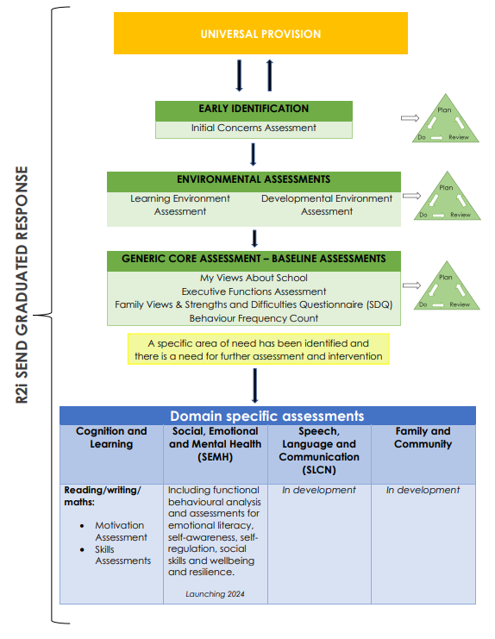

Speech, Language and CommunicationToolkit
Process Flow

