Name:
DOB:
Date of baseline:
Date of post assessment

Understanding Concepts
Lay the objects out and move them into different positions as you assess their understanding. Ask the child e.g. ‘what is behind the pencil case’. Make sure there is a contrast e.g. a rubber behind the pencil case and a paper clip in front of the pencil case.
Resources: Pencil case, big pencil, little pencil, big rubber, little rubber, paper clip, scissors.

Position:
☐ Big | ☐ Little | ☐ In | ☐ On | ☐ Under | ☐ In front | ☐ Behind
☐ Closest | ☐ Furthest | ☐ Next to | ☐ First | ☐ Last
Sequence:
☐ First | ☐ Last | ☐ Before | ☐ After

Vocabulary

Naming in Categories
Ask the child to name 5-7 things in each category. Give example of a different category if needed.
Resources: None.

Fruit | Things at the park | Things that are cold

Guessing Words and Giving Clues
Read the child clues and ask them to guess.
Resources: Pictures page 1.

☐ | Zebra | ☐ | Ruler | ☐ | Watermelon

Ask the child to give you clues. Encourage them to do this independently but offer prompts if needed.

Watch

Broccoli

Rhino

Defining Words
Ask the child to explain what the words mean. Give an example if needed ‘observe means to notice something’.
Resources: None

Connect

Brave

Synonyms
Ask the child to tell you at least 3 words that have the same or similar meanings. Give an example if needed ‘small – tiny, little, petite, teeny, mini’.
Resources: None

Big

Good

Antonyms
Ask the child to tell you at least 3 words that have the opposite or nearly opposite meaning. Give an example if needed ‘dry – wet, soaking, damp’.
Resources: None

Cold

Happy

Similarities and Differences
Ask the child to tell you 1 thing that is the same and 1 thing that is different. Give an example if needed.
Resources: None

Clock/watch

Running/swimming

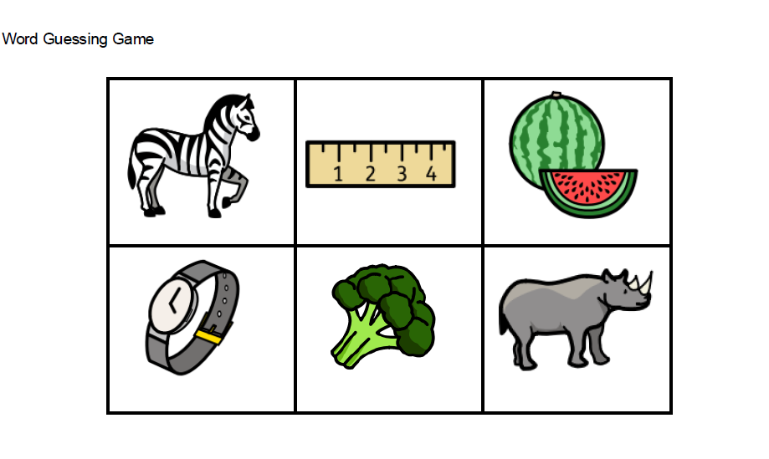
Total score (pre)

Total score (post)

Area where most improvement seen:

