Guidance for working on speech sounds
This document is intended to complement the video in this link.
Speech and language training videos and resources
(Introduction to speech sounds). Please use the screening tool included in the padlet, which is similar to that of Bedfordshire and Luton and permission has been given for this department and Devon’s to use their videos and screens.
Find out more about speech sound development | Nottinghamshire Healthcare NHS Foundation Trust

Developmental stages of English speech sounds
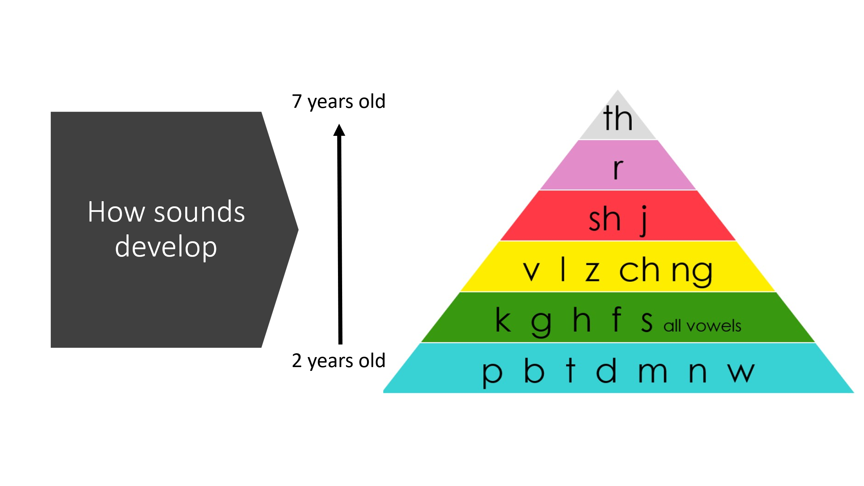
Younger children will often have unclear speech because some of their sounds have not yet developed. A 2-year-old will not have the sound ‘s’ in their speech sound system so the word ‘sea’ might be ‘tea.’ A 4-year-old might not be able to say ‘sh’ so words like sheep might be seep. But usually, they know what they mean to say! It can cause a lot of frustration.
By 6 children are usually very clear, and can say complicated words like ‘squirrel’ where there are three sounds before the vowel e.g. s k w (irrel). They can say some really long words like ‘helicopter’ clearly. They can string long sentences together and the sounds are still clear.
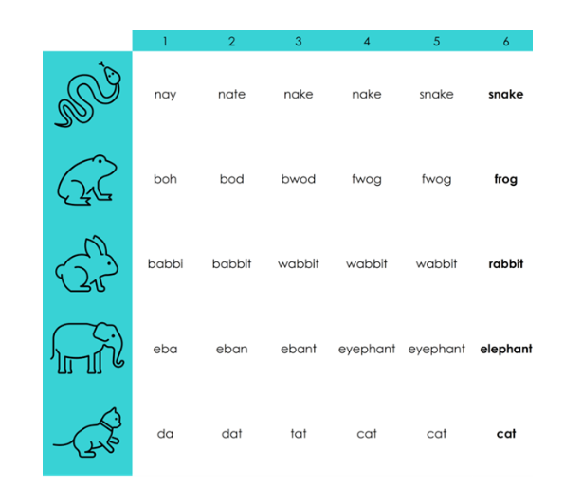
(Taken from speech therapy UK)
Above, are some examples of how children might say a word at various ages and stages of development. An older child with a genetic condition such as Down Syndrome may be later to develop some sounds and may need other methods of communicating to help them get their message across.
As a general rule, parents and close family should understand the child at 2 years old and by 3 even unfamiliar people should understand what they are saying, especially if there is some context, for example, you can see what they are talking about.
This would be the same in any language. Check with the parent that they can understand their child in their home language.
Speech sound difficulties can present on their own but can also co-occur with language learning difficulties too, and developmental conditions. Neurotypical and neurodivergent children, including autistic children and children with ADHD can present with speech sound difficulties. There may also be a family history of speech or language delay so check with the child’s parents.

Speech sound delay: The child’s speech is following the normal/typical pattern of development, but it’s happening slower than expected.

Speech sound disorder: The child’s speech is developing in an atypical way — not just slower, but different from typical patterns. The sound substitutions and errors are different to those seen in typical development, or the typical delayed processes remain ongoing, even when the child is much older.

Potential red flags / things to look out for:
- A young child not babbling – this will need to be checked with parents
- A young child mainly using only vowel sounds and very limited consonant sounds
- Inconsistent errors e.g. a child says the same word differently each time
- A young child substituting lots of sounds for the k/g sounds
- Listen for sounds made with more air coming out of the nose, especially on sounds like ‘s’.
- By school age most people should understand the child, even if some sounds are developing.

Speech processing model
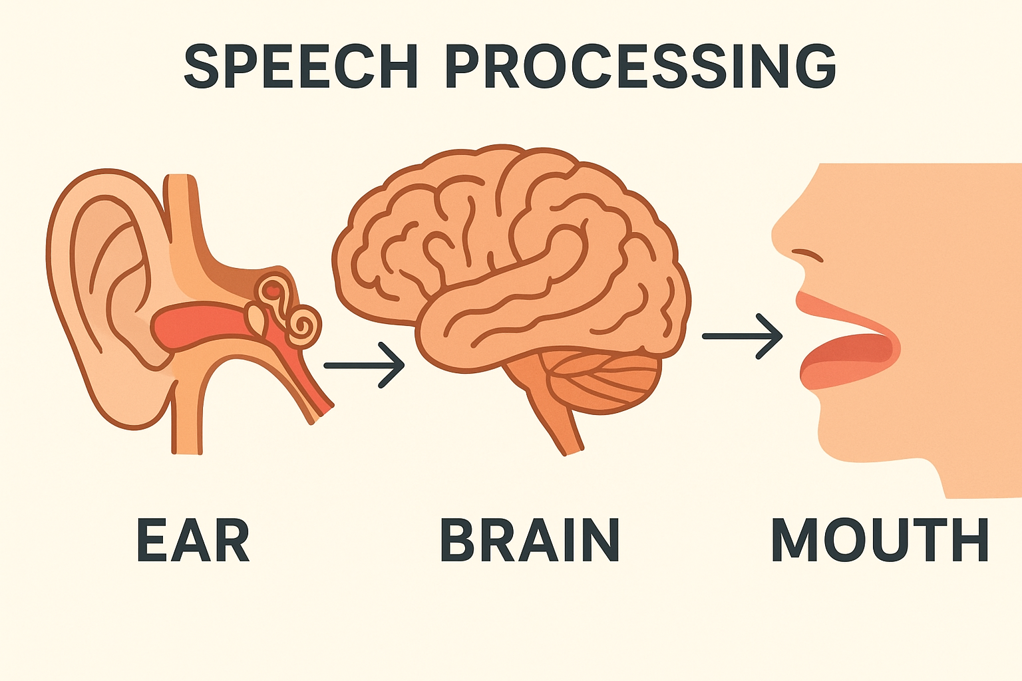
EAR-BRAIN (input to central processing)
- Most children first learn sounds and sound patterns in words by hearing the sounds and words around them.
- They might not understand everything, but the sounds and words pass through the ear, to the auditory nerve and to the brain and speech processing areas.
- This all starts to happen really early on in development, some argue, even in the womb. It is important that we talk to our children throughout the day, be face to face and repeat words from the moment they are born.
- Most children start to notice patterns in words. The ‘sound’ is the smallest unit of a word. It takes time for the brain to analyse and learn the sound patterns in the words in their home language.
- For example: Some words rhyme: cat, bat, hat. Some words all start with the same sound e.g. cat, car, coat, cake. Some words have lots of syllables, some do not: car, koala, caterpillar.
- Some children just cannot hear the sounds (they may be born with a hearing difficulty or have glue ear).
- OR they may have a specific difficulty sorting and analysing sounds and patterns.
- Check hearing if parents concerned
- Check the child can hear the difference between sounds. Can they recognise rhyme and identify syllables in words? This means doing activities that don’t require them to say anything, but simply match, sort or identify. (See NHS Borders Scotland booklet and Hertfordshire pack).

BRAIN (Central processing area)
- Children add ‘meaning’ to the words that they hear. This happens when they hear words over and over again in their environment and match the word to the object, action or concept.
- At first children learn the names of everyday objects that meet their needs, they learn some actions and social words such as hello, bye and some negatives like ‘no.’
- The ‘meaning’ of everyday words starts to happen much sooner than adding all the right sounds and saying the word correctly. e.g. a cat – this is an animal, has four legs, furry, goes meow, doesn’t like dogs.
- A child’s ‘brain’ has to do a lot of sorting and organising to understand that different words contain different sounds, then match them to their meaning. For example: key and tea – they rhyme but start with different sounds and the child knows that they mean different things.
- It is all quite a complicated thing to do. Most children do this by tuning in and listening. Some children find listening and tuning in tricky, which can make it harder to learn sounds and words.
- They also learn by good language models around them.

- Consider a child’s vocabulary development. They may lack enough experience of words to create and recognise similarities and differences.
- Keep checking their ability to hear the difference in words and what they mean.

BRAIN-MOUTH (output)
- Some children find it difficult to send some messages from the brain to the mouth to say the sound in a word.
- They might know what the sound should be, but along the journey from the brain to the nerves and to the muscles of the mouth and to the tongue and diaphragm the sound message gets jumbled up.

MOUTH (output)
- A child’s speech system changes rapidly from 2-5 years old.
- By reception age, everyone around them should understand them, even if there are still some sounds developing.
- Most children can send the sound they want to say from the brain to the mouth really well. They know what the word means. They know what the sounds should be, but when they get to the mouth the tongue doesn’t move to the right place, or the vocal cords bang together too much or too little, or too much air comes out of the nose.
- Some children have experienced structural differences to their mouth and articulators such as those seen in children with cleft lip or palate. Others will have no obvious anatomical difference but difficulties voluntarily moving and coordinating their ‘articulators’ (tongue, lips, soft palate and vocal cords)
The speech and language therapist tries to work out if a child has a difficulty with processing and storing sounds in the brain, or they have a difficulty sending the messages OR if it a difficulty saying the sound once it gets to the mouth area.
Some children can have a mixture of places where the difficulty might be.
Children who need help with the ear- brain and brain-mouth areas will need a different approach to those who only find the mouth bit difficult.

Common vocabulary
Deafness
Glue ear
Sensori-neural hearing loss
Auditory discrimination difficulties
Phonological awareness (recognising rhyme, syllables, alliteration)
Phonological disorder
Articulation difficulty
Cleft lip and palate

Place, manner and voicing.
The ‘place’ of articulation is where two bits of your mouth or throat come together to help make a sound. This makes the sound different from other sounds. E.g. for a ‘s’ your tongue meets your alveolar ridge (behind your teeth). For ‘f’ your teeth meet your lower lip.
A ‘manner’ of articulation is the way the air (from your lungs) passes through your throat, nose and mouth. This might be an open sound, like a vowel or a more closed sound like ‘s’ or ‘t’
Some sounds are loud and have your voice box turned on (e.g. ‘d’ or ‘z’) and some are quiet and your voice box is off (e.g. ‘t’ or ‘s’ ). This is known as ‘voicing’

Saying a sound is tricky

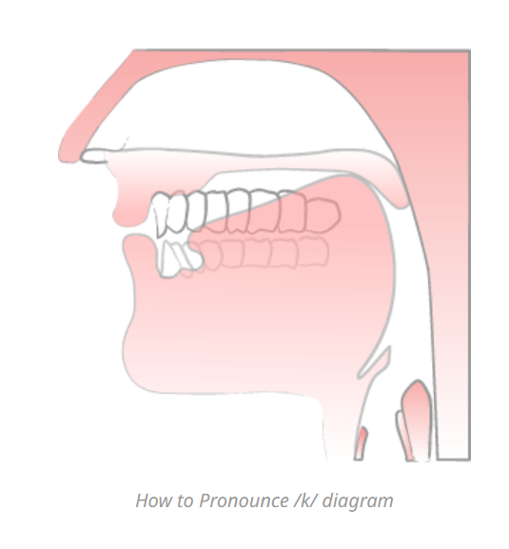
Back of tongue
Velum
(ref: Speak well, Jade Joddle).
Think about the sound ‘k’. To say this sound, we need the tongue to curl to the back of the mouth, with the back of the tongue hitting the velum, blocking the air to the nasal cavity so that air does not come out of the nose. Almost simultaneously our bodies then push air from the lungs, pharynx, then release the tongue from the velum/back of the mouth so that the air explodes out of the mouth.
Wow!
It is important that you seek advice from a speech and language therapist or professional who has had additional training in this area before you teach children how to say sounds.

What approach should you take?
Until you know which sound or sound pattern a child might find tricky, the best approach to take is to work on tuning in and listening. This will strengthen their ability to store and analyse sound patterns in words.
If a child needs speech and language therapy this will get them ready for therapy.
Examples
- Pairs games -match pairs that rhyme/ match pictures that start with the same sound
- Find something that rhymes with/starts with (sound)..
- Run to the sound I say (s, t, k/c, p, b) (stick pictures around the room).
- Feely bag – match the object/picture that rhymes, match the two objects with the same sound at the start
- Odd one out – 3 pictures, which word does not rhyme
- Sound bingo (example given is ‘s’ but you could make this for other sounds)
- Singing nursery rhymes, fill in the gap
- Clapping syllables in new words

Included in the Padlet is a phonological awareness pack from NHS borders Scotland and Hertfordshire which are good places to start.
For older children use pictures that correspond to some more topic vocabulary or their particular interest.

General strategies for parents and school staff
What you can do to help:
- Avoid correcting your child’s speech sound mistakes or asking them to say words again. Instead, repeat the word back to them in a natural way e.g. ‘tar’ → ‘oh yes, a car’.
- Be positive about what your child is saying rather than focusing on how they are saying it.
- Use a slow pace, with lots of pauses, so your child can clearly hear your speech. This should naturally help them to slow down their talking.
- Talk about things that you can both see.
- Reduce background noise when talking to your child, for example, turn off the TV/ music/ tablet.

What to do if you don’t understand what your child has said:
- Ask them to say it again, but in a positive way e.g. ‘my ears missed that, can you tell me again?’
- Ask your child to ‘show you’.
- Ask a few key questions.
- Repeat back what you did understand so your child only has to repeat what you have missed.
- Ask your child to tell you in a different way; they could try using a different word, using actions or gesture or older children could draw it or write it down.

