Assessment name | How it works |  | What it can tell you
SLCN Age-Specific screener  EYFS Age 3-4y 11mm | This screening tool is for use with children aged 3 years 0 months – 4 years 11 months to find out what support you can give the child in your setting.  It is also designed to support you in deciding when you need to refer to the Speech and Language Therapy service (SLT). This is based on the service’s referral criteria found here on our website: https://www.nottinghamshirehealthcare.nhs.uk/slt-how-to-refer  Please base your answers on the child’s first (strongest) language. The child should only be referred to SLT if he/she has difficulties in his/her first language. When assessing a child with English as an additional language, please bear in mind:  It can take up to 2 years for a child to acquire a good level of conversational ability in their second language.  It can take 5-7 years for the child to use the second language to process learning tasks in the same way as they would use their first language. |  | Children who score amber will require support with their speech and language development. You should look for advice on universal strategies and targeted interventions found here on our website:  Children who score red will require support with their speech and language development. You should look for advice on universal strategies and targeted interventions found here on our website: https://www.nottinghamshirehealthcare.nhs.uk/cslt-support-and-advice  Refer to speech therapy (use our criteria checklist) if a child scores red in any of these areas:  - Vocabulary and word finding  - Spoken Language/talking  - Speech sounds  - Stammering and voice  They may also score red in other sections too.  Continue to implement interventions in the padlet whilst the child is waiting to be seen by speech therapy.  Implement advice in the padlet for those scoring red ONLY in:  - Attention and listening or  - Understanding  Reconsider needs after this and if a referral is needed.  If a child scores red in the play and interaction/social communication section only, discuss with the SENCO if there are wider social communication needs and liaise with the specialist teacher team. This means that children who are verbally able but have some social communication needs may not meet speech and language therapy criteria at this point, but will still require some support.
Child’s Name: |  | DOB: |  | Date Completed:
School: |  |  | Completed By:

 | Screener Scores
 | - Social Communication the child can: |  |  |  |  |  |  | Score:  Yes = 1  No = 0
 | - Show an interest or enjoyment in interactions with others.
 | - Use eye contact during interactions.
 | - Use facial expressions during interactions.
 | - Use body language, movement (e.g., pulling), facial expression, or sounds, aimed at another person, to get their needs met (intentionally communicate).
 | - Point or gesture to communicate e.g., pointing when they want something, waving hello/goodbye and reaching to be picked up.
 | - Look when someone points at something.
 | - Enjoy an adult joining in their play.
 | - Demonstrate pretend play skills (such as putting a baby to bed, feeding a cuddly toy).
 | - Play alongside other children (i.e., engage in similar play activities in close proximity).
 | - Play with other children (i.e., join in and share play ideas).
 | Social Communication: total score
 | Circle R,A,G according to their score à |  | Red |  | Amber |  |  | Green
 | Chronological Age 3y 0m – 3y 11m |  | 0-6 |  | 7-8 |  |  | 9-10
 | Chronological Age 4y 0m – 4y 11m |  | 0-7 |  | 8-9 |  |  | 10
 | - Understanding the child can: |  |  |  |  |  |  | Score: Yes = 1 No = 0
 | - Follow instructions with two parts such as, “show me teddy’s eyes” or “get dolly’s shoes”.
 | - Understand familiar action words e.g. eat, run, sleep, cry.
 | - Follow longer instructions (three+ parts) without adult support e.g. “go to your bedroom and find a big teddy”.
 | - Answer simple questions e.g. who? what? where? questions based on what is happening at the time.
 | - Repetition Instead: Understands concepts such as big/little, hot/cold and prepositions such as in/on/under.
 | Understanding and Processing Language: Total Score
 | Circle R,A,G according to their score à |  | Red |  | Amber |  |  | Green
 | Chronological Age 3y 0m – 3y 11m |  | 0-1 |  | 2-4 |  |  | 5
 | Chronological Age 4y 0m – 4y 11m |  | 0-2 |  | 3-4 |  |  | 5
 | - Talking the child can: |  |  |  |  |  |  | Score: Yes = 1 No = 0
 | - Make their basic needs known.
 | - Name lots of everyday items.
 | - Join two or more words together.
 | - Uses lots of action words.
 | - Use words in the right order in a sentence.
 | - Join in with a conversation about what is happening now using simple sentences.
Spoken language: total score
NB: If the child has a stammer/stutter please refer to speech and language therapy.
 | Circle R,A,G according to their score à |  | Red |  | Amber |  |  | Green
 | Chronological Age 3y 0m – 3y 11m |  | 0-2 |  | 3-4 |  |  | 5-6
 | Chronological Age 4y 0m – 4y 11m |  | 0-2 |  | 3-4 |  |  | 5-6
 | - Speech sounds – please complete the BDCFT speech sound screen. |  |  |  |  |  |  | Score: Yes = 1 No = 0
 | - The child is understood by parents/carers.
 | - The child is able to use ‘early developing’ consonant sounds when talking e.g. p, b, m, n, w.
 | - The child is able to use ‘middle developing’ consonant sounds when talking e.g k, g, f, s
 | - The child is able to accurately use the end sounds of words e.g. ‘n’ in ‘bun’.
 | - The child is understood most of the time by less familiar adults.
 | Speech: total score
 | Circle R,A,G according to their score à |  | Red |  | Amber |  |  | Green
 | Chronological Age 3y 0m – 3y 11m |  | 0-2 |  | 3-4 |  |  | 5
 | Chronological Age 4y 0m – 4y 11m |  | 0-3 |  | 4 |  |  | 5
- Other (including stammering and voice) |  |  |  |  |  | Score: Yes = 1 No = 0
- The child’s talking is fluent and smooth when they speak.
- The child can use words and sentences confidently and is not avoiding words or speaking situations
- The child is showing no evidence of a stammer such as repeating parts or whole words, or showing a struggle or tension when they talk
- Voice is clear, with no evidence of pain or strain when talking, or raspy sound.
Stammering: total score
Circle R,A,G according to their score à  Any score less than 4 is an immediate referral to SALT |  | Red |  | Amber |  |  | Green
 |  |  |  |  |  |  | 4

SLCN Area | RAG Rating |  |  | Impact Rating |  |  |  |  |  |  | Total Impact Score
 | Tick the RAG rating from screening results for each SLCN area. |  |  | Ask the question “How much does the child’s difficulty negatively impact their a) learning b) interaction and friendships c) happiness and wellbeing?”  Using the following scale: |  |  |  |  |  |  | (Add impact score of a, b and c to create total per SLCN area)
 |  |  |  |  |  |  |  |  |  | 
 |  |  |  | No impact | Minor |  | Moderate | Major |  | Severe
 |  |  |  | 0 | 1 |  | 2 | 3 |  | 4
 |  |  |  | Write the numbers in the boxes below:
 | Red | Amber | Green | A |  | B |  |  | C
 |  |  |  | Learning |  | Interaction & friendships |  |  | Happiness and wellbeing
- Social Communication
- Understanding
- Talking
- Speech Sounds
- Other

Next Steps
Red | If more than one area scored red, use the Total Impact Score to guide the primary focus of targeted intervention i.e., whichever red SLCN area has the highest impact score - focus targeted intervention on that area. | https://www.nottinghamshirehealthcare.nhs.uk/download/slt-referral-checklist-april-2024.doc?ver=28027&doc=docm93jijm4n4248.doc  https://www.nottinghamshirehealthcare.nhs.uk/download/slt-referral-form-2024.docx?ver=28026&doc=docm93jijm4n4627.docx  Complete baseline measure (the targeted intervention will usually include one). Deliver appropriate targeted intervention.  Re-do baseline measure after a term’s input to monitor response to intervention.  Consider, do they now meet the Nottinghamshire SALT RED referral criteria? If yes – consider the impact of the SLCN. If the impact is moderate - severe make a referral to SALT team. Include details of your screening results and targeted interventions with your referral.
Amber | If there are no Red areas, and more than one area scored Amber, use the Total Impact Score to guide the primary focus of targeted intervention i.e. whichever Amber SLCN area has the highest impact score, provide targeted intervention for this. Follow the same steps as detailed above, however, referral to the SALT service is not indicated.
Green | No intervention required. QFT

Name of child/ young person (CYP): |  | Class: |  | REVIEW DATE:
Immediate Referral to SALT Required  (alongside targeted intervention) |  | YES | NO
Review targeted Intervention before deciding A SALT Referral is Required |  | YES | NO
NO SALT Referral Required |  | YES | NO
Area targeted for development | Intervention / strategy | Rate  Effectiveness of intervention  0-5  0= no impact  5=full impact |  | Progress made at review date/ comments
1.

2.

3.

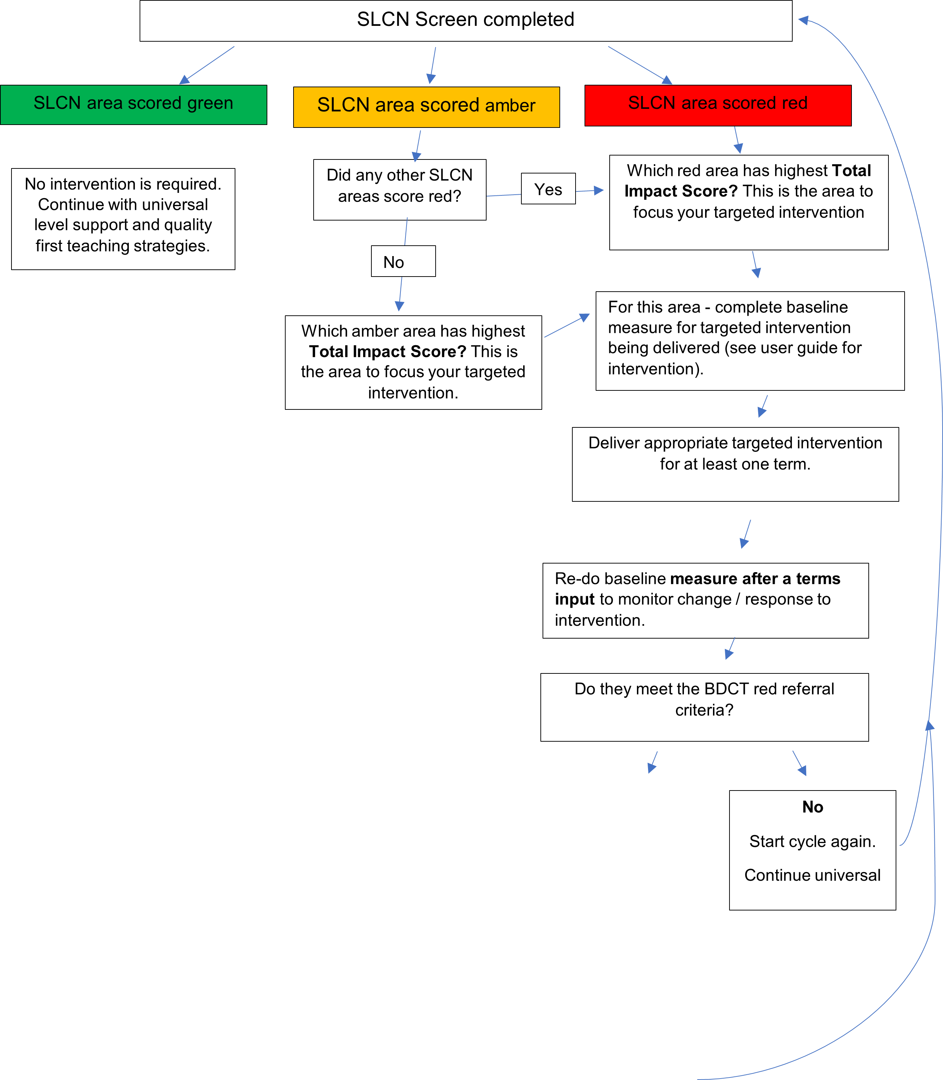
Do they meet criteria for a SALT referral?
dDdo
Yes
Make referral to SALT team. Include copy of:
- Information about the targeted intervention delivered (what and how much/ how long) and progress evidenced.
- Most recent screening results (can be Nottinghamshire SLT/R2i’s screen or a published resource e.g. Progression Tools, Wellcomm, etc… )
- Continue universal and targeted support whilst awaiting specialist support.

