Writing Skills Assessment Summary Sheet
This sheet should be used to track results of your assessments with the child/young person.

Child: ……………………………………….……. Date: …………………………………..…..

Assessor: ……………………….…………..School: ……………….……………………………

NB. Please ensure that you have completed the baseline assessments (and implemented and reviewed any strategies) from the SEND toolkit before exploring reading needs.
Assessment | Completed
Initial concerns assessment | Yes/No
Developmental environment assessment | Yes/No
Learning environment assessment | Yes/No
My views about school | Yes/No
Family views questionnaire & SDQ | Yes/No
Executive Function Assessment* | Yes/No
Frequency Count | Yes/No

Component Area | Sub-component Area | Competence in this area? Y/N
Executive Functions* | Is the young person able to utilise their working memory effectively?
Executive Functions* | Does the young person have functioning inhibitory control?
Executive Functions* | Does the young person have functioning cognitive flexibility?
Motivation | Is the young person motivated to write?
Domain skills | Spelling
Domain skills | Child’s spelling skills are in line with peers?
Domain skills | Handwriting
Domain skills | Young person has adequate handwriting skills?
Domain skills | Composition
Domain skills | Does the young person have adequate vocabulary?
Domain skills | Is the young person able to generate lots of ideas?
Domain skills | Young person is able to write sentences that make sense?

*Note that executive functions sit at the heart of the writing pyramid in Figure 1, this is due to their central role in the writing process, particularly when children are expected to write longer texts. Working memory is particularly important as the child must hold and manipulate large amounts of information when writing, including, sound-to-letter pairings, motor patterns needed to visually produce letters, what has already been written, what they are writing, and what they plan to write next. If the child’s working memory capacity does not allow them to hold this information we will see spelling errors, messy handwriting, and texts that do not make sense. Additionally, children may have limited cognitive capacity left to engage in more complex writing skills that make texts interesting to read.

Executive functions are also fundamental to successful planning and editing, which, particularly in longer texts, are essential to the writing process. Therefore, limited executive functions may mean that children do not plan, check, or edit their work.

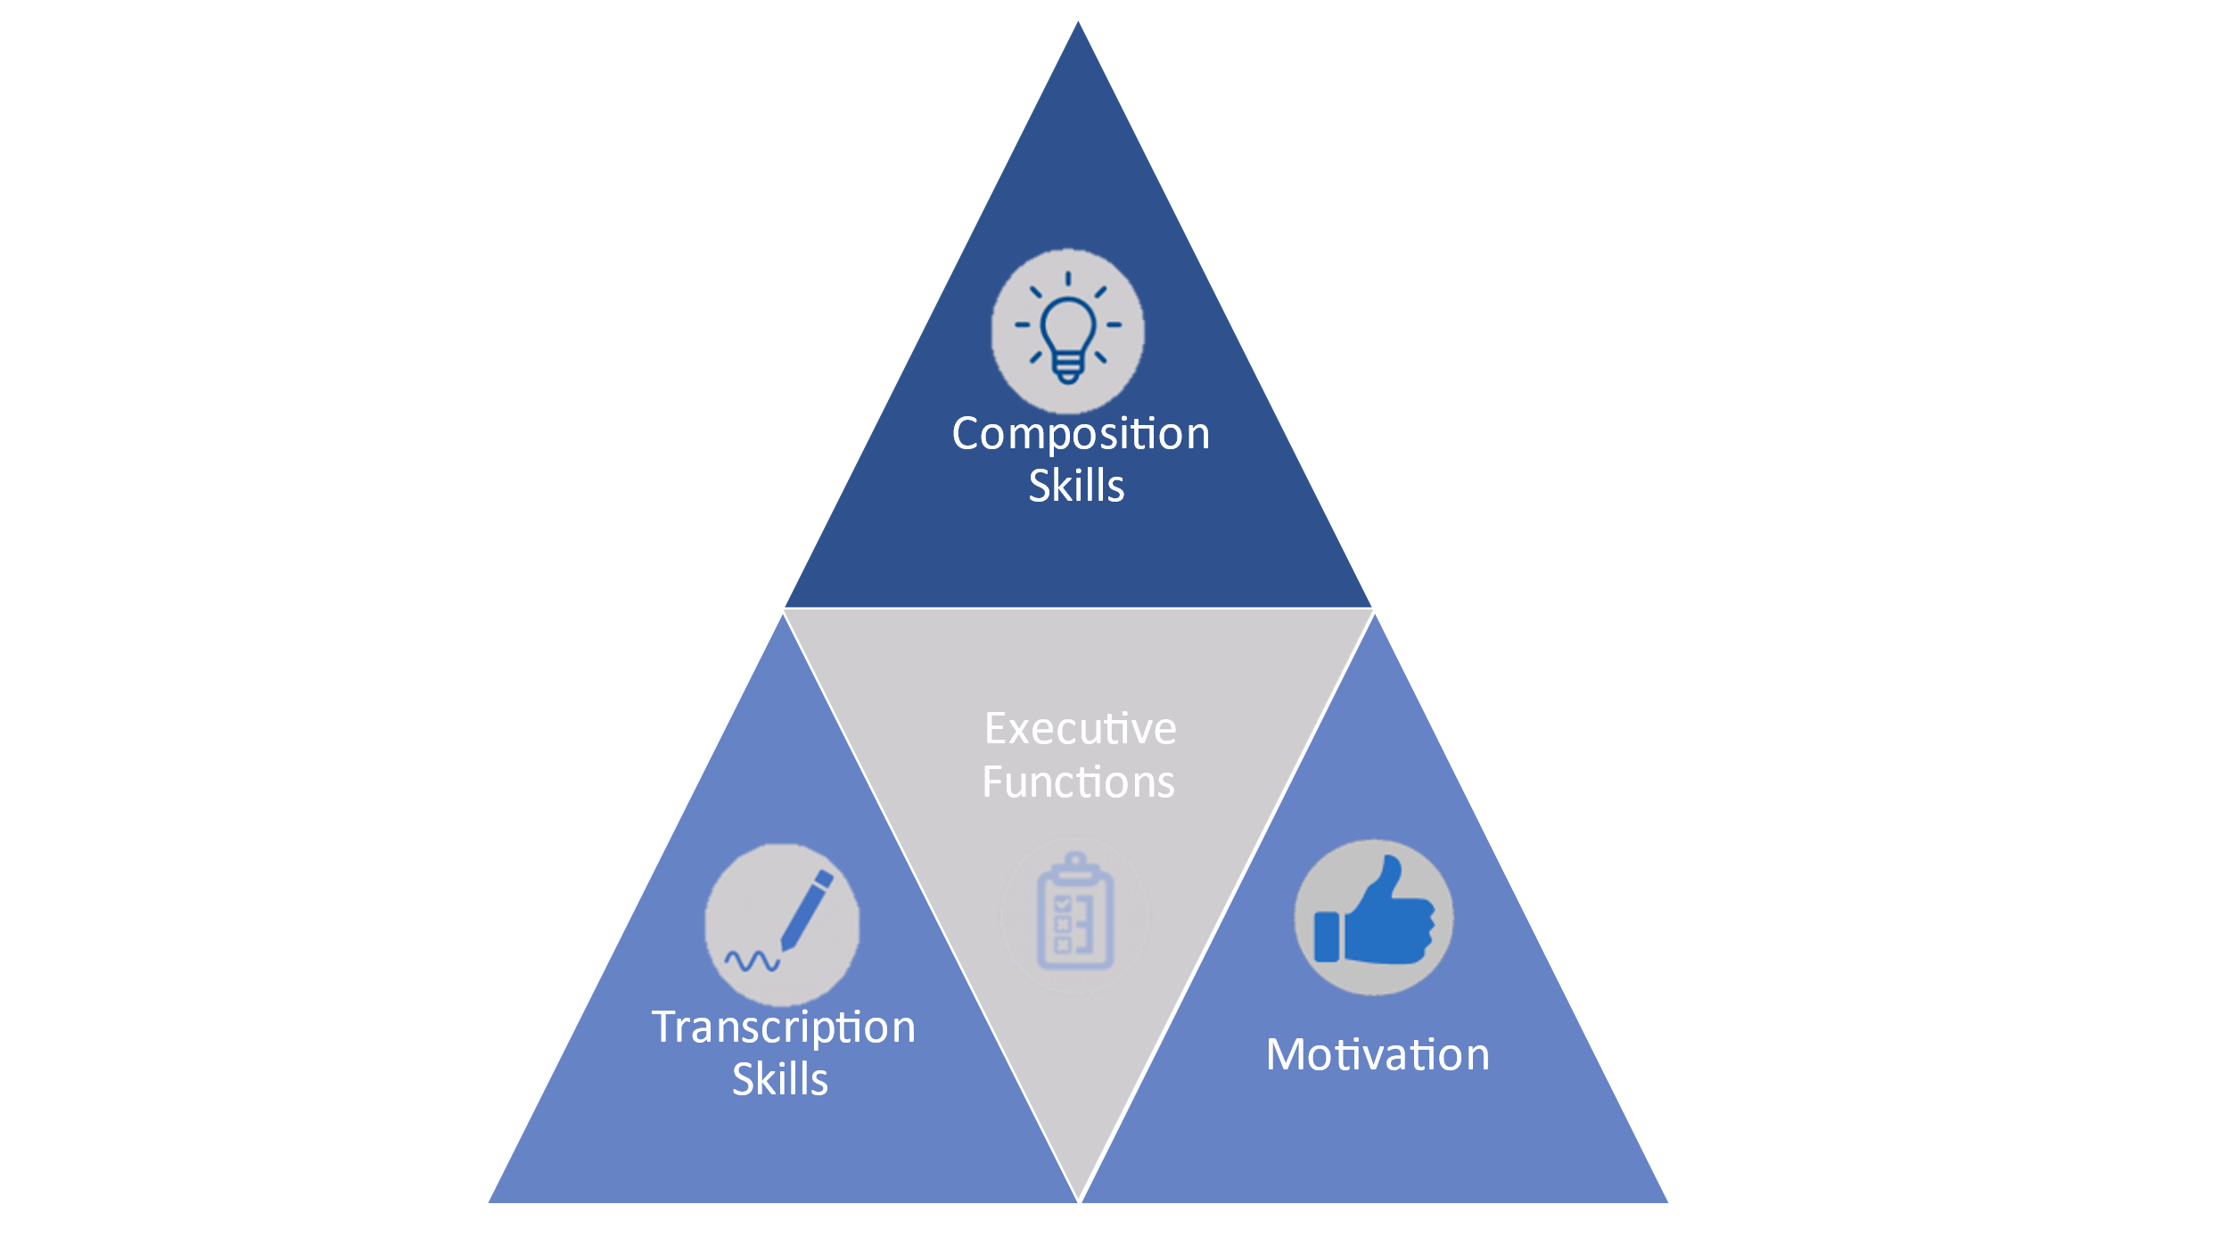
Figure 1. Visual Depiction of the Sub-Components of Writing

When writing, executive function difficulties could present as:
- Texts that contain multiple spelling errors – particularly where the final letters of the word are missing.
- Very messy handwriting.
- Words missing from sentences.
- Texts that do not make sense.
- Texts that appear disjointed.
- Texts that appear to jump from one idea to another with no link.
- Difficulties with planning – e.g. no plan, a plan is made but not used.
- Limited reading back of writing to check for coherence.
- Limited self-correction/editing when writing.

If the child is displaying any of the above and you have not completed the executive functions checklist, please complete the executive functions checklist before continuing.

